**BENG 212 Final Report**

**Revealing location-specific variation and drug transport specificity in the Allen Brain Atlas**

Kevin Rychel and Margot Wagner

3/22/19

**Abstract**

This project analyzes single subject RNA-Seq data from the Allen Brain Atlas for clinically healthy patient. Here we look to see if there are significant variations in gene expression data between regions at different resolutions and if that data can be used to determine localization of drug behavior based on chemical similarity to metabolites transported by transporters genetically expressed. We find that this dataset can be used to train and test models to predict brain region information at lower structure-level resolutions, but more information would be needed to reach substructure or molecular resolutions. This can highlight important gene features associated with various regions of the brain, giving insight to their functions. Additionally, gene expression can be mapped from genes to transporters to metabolites to drugs, but more information on metabolites would be required. The cerebellum uptakes drugs with the highest activity compared to the cortex and brainstem.

**1. Introduction**

**1.1. Background on the Allen Brain Atlas**

The Allen Brain Atlas is a project by the Allen Institute for Brain Science that began in 2003 whose goal is to create gene expression maps for the human brain by combining anatomical and genomic information with visualization and data mining tools to view areas of differing gene expression in the brain and correlate between gene expression, cell types, and pathway functions in relation to observed behaviors or phenotypes.1,2 Specifically, the Allen Institute for Brain Science aims to obtain insight on neurobiological conditions such as Parkinson’s disease, Alzheimer’s disease, and autism.1 There are currently eight different brain atlases including the Human Brain Atlas, which was originally published in May 2010 as the first anatomically and genomically comprehensive 3D human brain map.1,2 The goal of the original Human Brain Atlas is to enhance research by systematically profiling gene expression throughout all major regions of neurotypical (‘control’) adult human brains, then comparing with brains of patients with neurological disorders and brain injuries. The Allen Human Brain Atlas was put together with two main features, an ‘all genes-all structures’ microarray-based gene expression profile and complementary in situ hybridization (ISH) gene expression studies. In the former, genome-wise profiles are obtained from the cortex, subcortex, cerebellum, and brainstem. Currently, this allows for genomic and anatomical searches, and the data is also accompanied by histology-based neuroanatomical annotations mapped onto magnetic resonance image (MRI)-based brain representations in both 2D and 3D. In addition to this genome- and structure-wide dataset for the human brain, ISH gene expression studies targeting selected genes in specific brain regions allow for visualization of specific cells in which the genes are expressed in both normal and disease brains.1,2 At the time the Allen Human Brain Atlas was being created, RNA sequencing (RNA-Seq) was still immature, so the atlas was created from microarray data.2 With that being said, microarray data tends to have issues with cross-hybridization artifacts and poor quantification of lowly and highly expressed genes.3 On the other hand, RNA-Seq is more quantitative in nature, has greater dynamic ranges, and contains higher information content.2 The Allen Brain Atlas has RNA-Seq data for two patients available for download, but it is not integrated into the other features of the site. As a result, much of the existing landscape for gene expression data analysis utilizing the Allen Brain Atlas has been using microarray data, creating a need for RNA-Seq analysis.1

Since its inception, the atlas has been used in multiple studies to answer a multitude of questions about the human brain. For example, the microarray gene expression data was mapped both globally and locally, and it was found that variations in transcriptional regulation differed by anatomical regions and cell types. The neocortex could be separated from subcortical regions, for example, and within both the cortex and subcortex, biological substructures emerged based on transcriptional data. Additionally, neurotransmitter-specific genes could be mapped topographically across brain regions. Transcriptional variation also strongly reflected major cell types, both neuronal and non-neuronal. Overall, it was shown that the adult human brain transcriptome could be used to accurately recapitulate the spatial anatomy of the brain. This study was done using microarray data, and it is expected that similar conclusions can be obtained utilizing RNA-Seq data.4 Another publication looked at genetic signatures of the adult human brain using microarray data from the Allen Human Brain Atlas to identify the core transcriptional machinery conserved across individuals. It was found that genes with the most reproducible patterns between adult human brains are strongly biologically relevant, and the patterns correspond to cell types and cellular functions.5

In this study, we look at RNA-Seq data for the entire brain of one subject. The subject was a 39-year old African American male with no known history of neuropsychiatric or neurological conditions (‘control’). Additional post-mortem tests and quality measures were done to ensure tissue and RNA met the quality control (QC) criteria and the ‘control’ label. This subject was selected as the data displayed higher RNA quality compared to the other subject, perhaps as a result of his shorter time between death and tissue harvest. A single subject was selected in order to interpret the personalized transcriptome to help better understand transcriptomic changes happening within subjects with the goal of eventually identifying gene drivers for disease and specific targets for drugs. The single-subject data set consists of 22,318 genes from 121 samples across 10 main brain structures containing 29 substructures, and 82 specific ontology identifications taking into account brain lateralization, superior or inferior, and lateral or medial.1 From our expression data, we will look specifically at the expression of transporters to inform spatially targeted drug discovery. It has been shown that cellular transmembrane drug transports occur by transport-mediation by existing membrane transport proteins.6 By identifying transporters that are highly differentially expressed in target brain regions, then using cheminformatics, specifically the Tanimoto index for fingerprint-based similarity calculations, to compare transporter substrates with chemically-similar known drugs or potential drug structures, we hope to establish a drug to brain region mapping.7 This would inform treatment options and off-target effects of drugs for brain diseases such as Alzheimer’s, Parkinson’s, or bipolar disorder.

**1.2. Chosen Dataset**

**1.2.1. Dataset Selection and Preprocessing**

In this study, we look at RNA-Seq data for the entire brain of one subject. The subject was a 39-year old African American male with no known history of neuropsychiatric or neurological conditions (‘control’). **Figure 1.1** shows an anatomical recreation of the subject’s brain from MRI data. Additional post-mortem tests and quality measures were done to ensure tissue and RNA met the quality control (QC) criteria and the ‘control’ label. This subject was selected as the data displayed higher RNA quality compared to the other subject, perhaps as a result of his shorter time between death and tissue harvest. A single subject was selected in order to interpret the personalized transcriptome to help better understand transcriptomic changes happening within subjects with the goal of eventually identifying gene drivers for disease and specific targets for drugs. The single-subject data set consists of 22,318 genes from 121 samples across 10 main brain structures containing 29 substructures, and 82 specific ontology identifications taking into account brain lateralization, superior or inferior, and lateral or medial.1

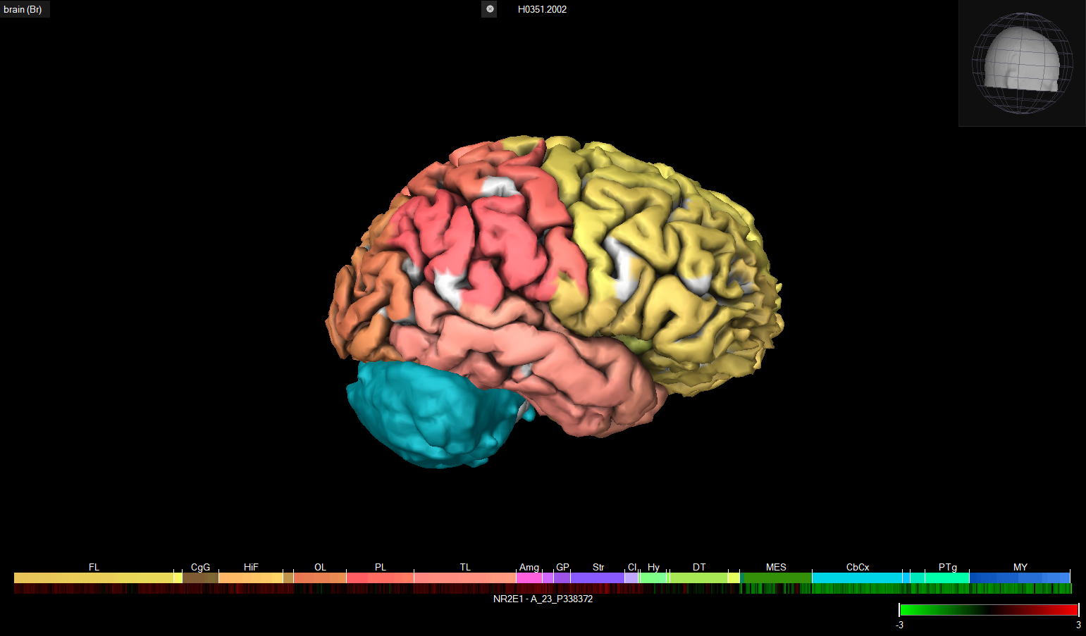

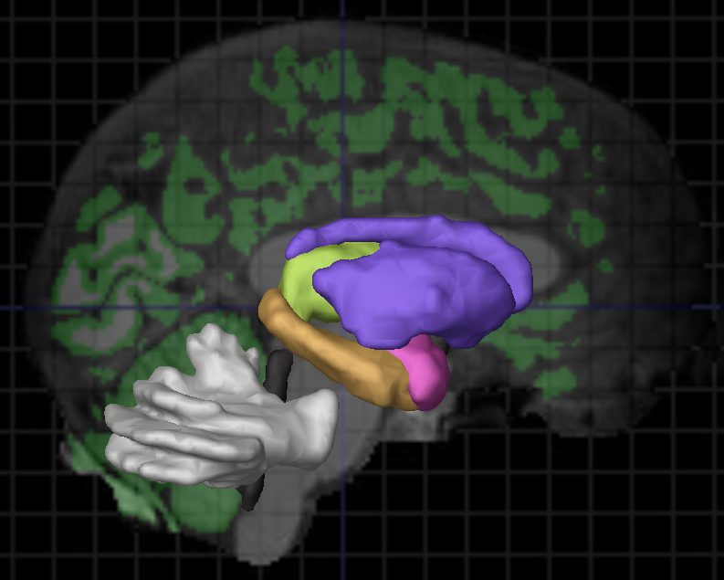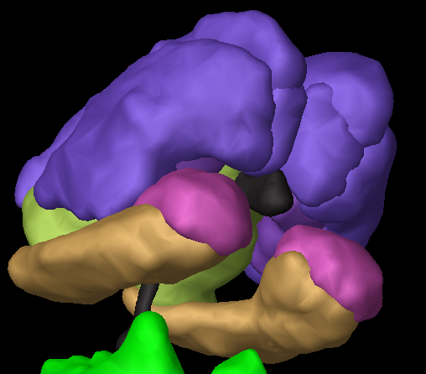

***Fig 1.1:*** *Anatomical reconstruction of subject’s brain including main brain regions using Brain Explorer 2 software.*

Prior to analysis, genes were removed to improve performance if they met any of the following criteria:

1. The count is less than 20 fragments in all samples (removes 13,140 genes)

2. The median gene length is shorter than 100 bases (removes 1,049 genes)

3. The gene has constant expression across all samples (removes 1,590 genes)

Lowly expressed and short genes tend to have very high variance in RNA-Seq data because sequencing involves a sampling process which is Poisson-distributed over length and read number – at low values of either, there are not enough fragments within the gene to accurately predict TPM.15,16 Constant expression genes do not contribute to variance between regions whatsoever, and they create 'divide by zero' errors with data normalization. After removing all these genes, 7,530 genes remained in the dataset. This large reduction is expected because many genes are tissue-specific and therefore would not be expressed highly in the brain.

We took the log(TPM + 1) of the dataset for analysis. This is done because RNA expression is log-normal distributed, so highly expressed genes will have artificially high variance compared to the rest of the data. 1 is added to the data before taking the logarithm to avoid log(0) problems.

After removing undesired genes, we confirmed that there were no technical issues with any of the samples by computing correlations between gene expression in replicate and non-replicate pairs of samples as shown in **figure 1.2**. All 5 replicates have R > 0.9, so we have demonstrated that the dataset is consistent between its biological replicates.

The histogram (**figure 1.2**) shows a wide distribution with many non-replicate samples that are highly correlated, and some pairs that are very lowly correlated. The high correlations come from brain regions that are very similar - all 5 are pairs of various gyri, which are ridges in the cerebral cortex responsible for higher functions. Interestingly, the pairs are not all from the same hemisphere, which indicates that lateralization is not important for describing transcriptomic differences between these structures.

Without biological replicates to check the lowly correlated samples against, it is impossible to know whether this dissimilarity is the result of experimental error or real biological differences. However, all the top 7 arise from the putamen, which is a deep brain structure that is expected to be vastly different from the outer cortex structures.

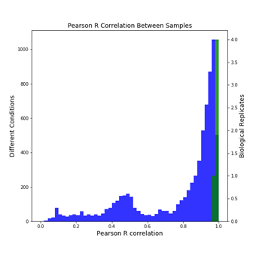

***Fig 1.2:*** *Pearson R correlation between different conditions (blue) and biological replicates (green). Biological replicates have high correlations, as do some non-replicates.*

Additionally, we looked at the covariance matrix of the data, indicating the level to which two genes vary together. Here we are looking at the normalized covariance, which is equivalent to correlation. Positive covariance implies a positive relationship between to variables while negative implies an opposite relationship. Zero covariance means no relationship. As we are looking at the normalized covariance, the values range from [-1,1].

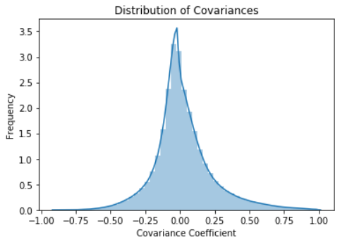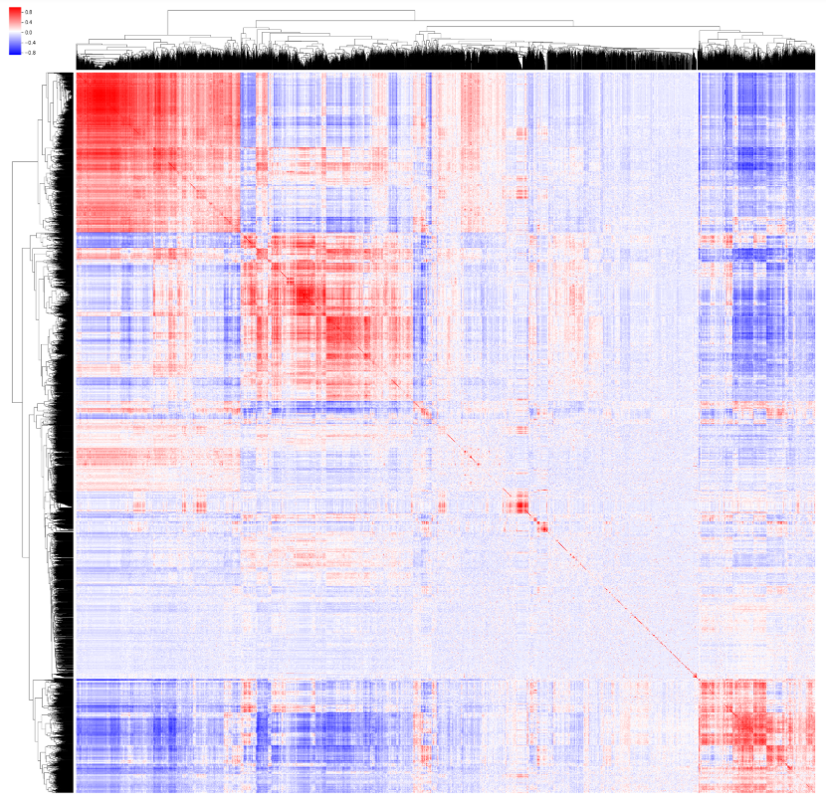

***Fig 1.3:*** *Covariance matrix analysis including distribution of covariances (left) and a colormap (right). On the colormap used, red indicates positive correlations and blue indicates negative.*

The distribution of covariances (**figure 1.3 left**) is very sharp in the middle and highly tailed, indicating that most genes are uncorrelated (middle peak) but that various levels of correlation do exist. The distribution is skewed with a large right tail, meaning that most correlations are positive rather than negative - related genes are usually turned on together, not 'one or the other' binary switches. The colormap (**figure 1.3 right**) shows several box-like structures along the diagonal of relatively higher correlated genes, as well as a subset of genes that are very noisy (no correlations with other genes). Overall, this transcriptome appears highly complex.

**1.2.2. PCA**

To get a better sense of the data, we performed PCA to look at each sample in lower dimensional space. We are interested in which genes make up the top three principal components, the cumulative explained variance of the components, and how samples map onto principal component space.

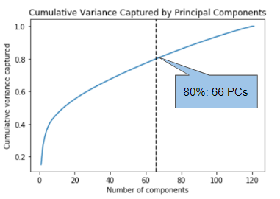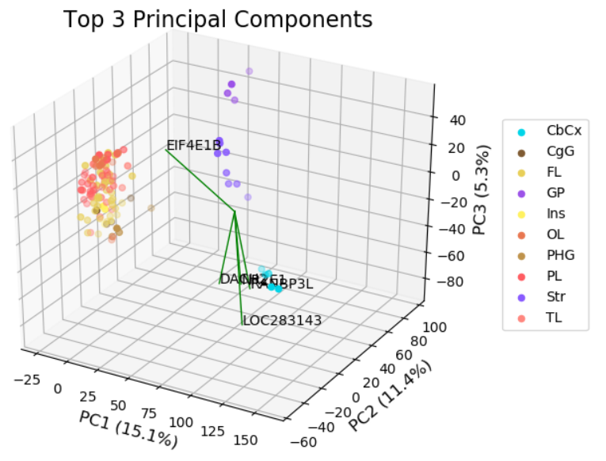

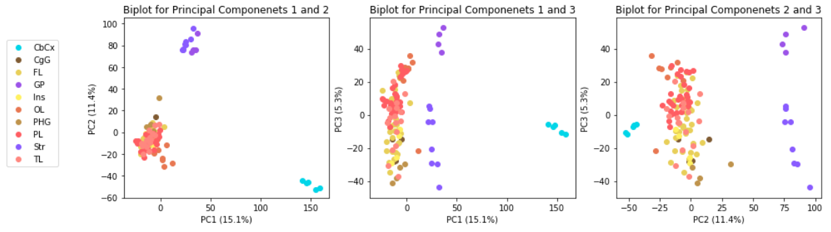

***Fig 1.4:*** *Full dataset PCA results. The cumulative explained variance captured by number of components (top left), the top 5 genes mapped onto the top three principal components (top right), and two-dimensional PC analysis of the main structures (bottom).*

From the cumulative explained variance plot in the top left of **figure 1.4**, we see we need about half the components to capture even 80% of the cumulative variance. This suggests that spatial localization of RNA transcription is highly-dimensional in a human brain. As opposed to single-cell organisms, it obvious that the gene expression across the entire brain cannot be as easily represented by typical data analysis and reduction methods. Additionally, because the principal components explain such a small amount of variance, it is likely the variance is not solely do to regional differences. Due to the complex nature of the brain and the high number of different cell types within each region, there is likely gene expression variations by cell type even within regions. An interesting further analysis would include looking at single cell gene expression data to determine if there are more informative clustering patterns in principal component space.

From the samples mapped onto the top principal components in both two- and three-dimensional space as seen in the top right and bottom figures of **figure 1.4**, we see a clear separation between the cerebellum (CbCx, highlighted in blue), the brainstem structures (globus pallidus, GP, and striatum, Str, highlighted in purple), and the cortical structures (the remaining colors). Colors used here match those shown in **figure 1.1**. This separation is the motivation for further analysis at a three-region resolution, with samples separated by cerebellum, brainstem, or cortex. Additionally, we see strong clustering of brainstem and cortical samples when the first and second PC are graphed (leftmost graph in bottom of **figure 1.4**), but the samples seem to spread out more with the inclusion of the third PC suggesting it may contain vital information differentiating between these regions at a higher resolution. Further suggesting this is that four of the top five genes are across the third principal component.

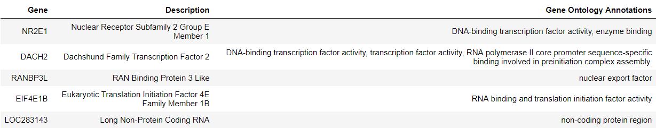

***Table 1.1:*** *Top five highest weighted genes across the three principal components with the largest explained variance.17*

The top five highest weighted genes are shown in **table 1.1**. The top two genes, NR2E1 and DACH2, are both transcription factors with the fourth highest weighted gene, EIF4E1B, also being a translation factor. Given that only approximately 10% of genes in the human genome code for transcription factors, this is an interesting find suggesting transcription is region-specific and function-specific in the brain.18

In **figure 1.5**, we used the Allen Brain Atlas software Brain Explorer 2 to look at the gene expression levels of the top weighted gene in the PCA analysis, NR2E1. This mapping highlights that, while there are other sources of variation, the principal components do capture regional information. From this image we can see the NR2E1 is not highly expressed in the cerebellum and brainstem which are bright green while the cortex displays more red, indicating higher expression rates of NR2E1 in the cortex than the other regions. NR2E1, or Nuclear Receptor Subfamily 2 Group E Member 1, encodes an orphan receptor protein involved in retinal development. 18 Understandably, we see higher expression in the cortex as the cortex is closer involved with retinal development, but as it is not directly cortical in nature, we do not see very high expression in the cortex.

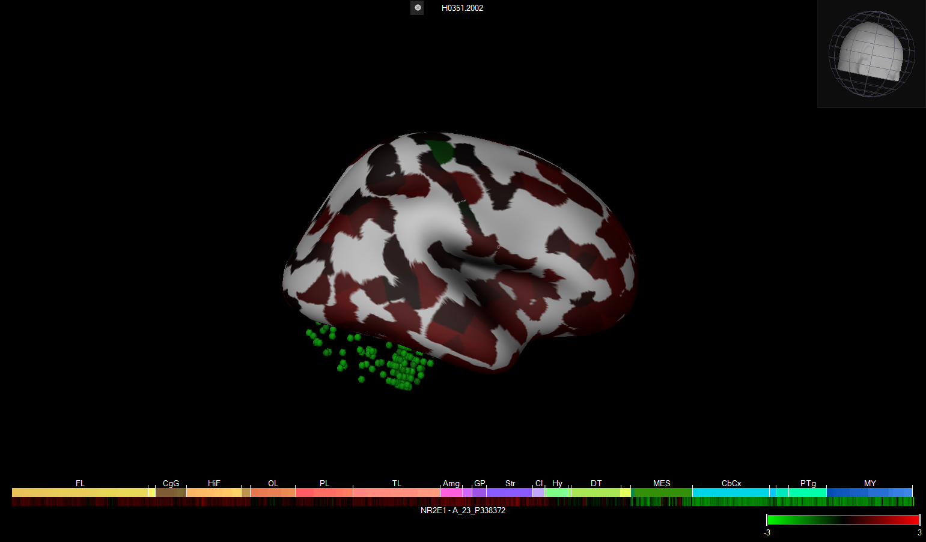

***Fig 1.5:*** *Mapping of NR2E1 expression onto subject’s brain using Brain Explorer 2. Colors indicate the Z-score of the log2-transformed expression with green indicating low expression and red indicating high expression.*

In previous analyses, it has been shown that PCA of solely the cortex pulls apart higher resolution differences between cortical regions.4 The overall PCA shows 3 clusters that differentiate based on cortex, cerebellum, or subcortex. While this is important information, the majority of samples still fall under the umbrella of cortex. A low percentage of explained variance is captured by the top components of PCA of the overall dataset, and this could be due to the variance within the cortex that is not fully captured at this level. Our hypothesis was that further PCA analysis of solely the cortex should tease apart higher resolution information about different regions within the cortex.

From **figure 1.6** we see the principal component analysis of the cortex does not cluster as well as we had hoped. Interestingly, there is not clear separation between the frontal lobe, occipital lobe, parietal lobe, and temporal lobe. This suggests gene expression in these regions is non-unique. The cingulate gyrus, CgG, is spread within the regions where there is primarily Frontal Lobe, which makes sense as the cingulate gyrus is near the frontal gyrus in the brain. Similarly, the temporal lobe samples are seen near all lobes, which reflects also being next to all lobes in the brain. On the other hand, the occipital lobe, for example, shows more separation from the frontal lobe than the temporal or parietal lobe. The smaller regions, such as the insula and parahippocampal show more clustering compared to the larger lobe regions. Overall, there is not nice clustering between other regions, but the location of the regions in the brain is reflected in the spread of samples in principal component space where regions that are closer in physical space are also closer in principal component space.

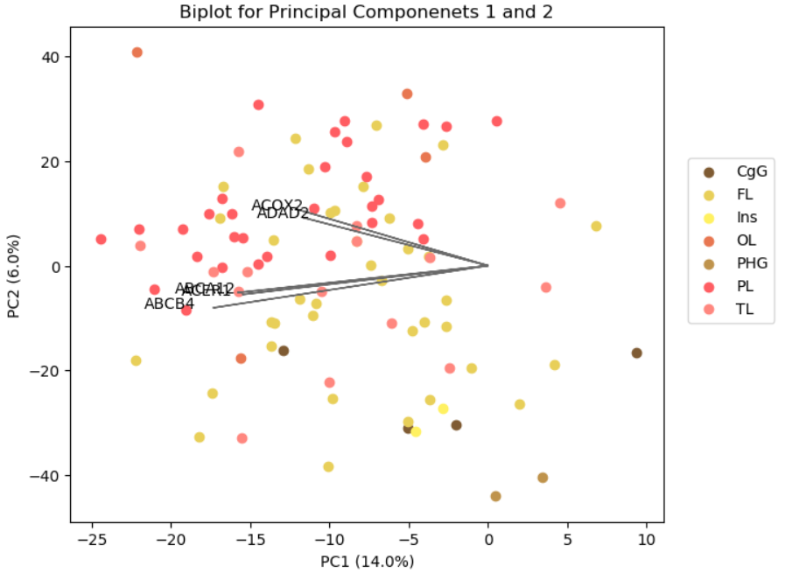

***Fig 1.6:*** *Two-dimensional cortical PCA results with the top five highest weighted genes included.*

Additionally, we were able to take away the top genes associated solely with the cortex of the brain, which were different than those associated with the entire brain dataset (**table 1.2**). This makes sense as we saw NR2E1 was not highly expressed throughout the cortex. Interestingly, we no longer see any transcription factors in the list of top genes. Instead, we have two genes involved in signaling receptor binding and two involved in the same transporter, ATP-Binding Cassette. ATP-binding cassette (ABC) transporters are ATP-dependent pumps found in the blood-brain barrier, amongst other areas. ABC transporters participate in the movement of most drugs and their metabolites and are known to have mutations that cause severe inherited diseases (i.e. cystic fibrosis) making its differential expression across regions of the brain of particular interest.19

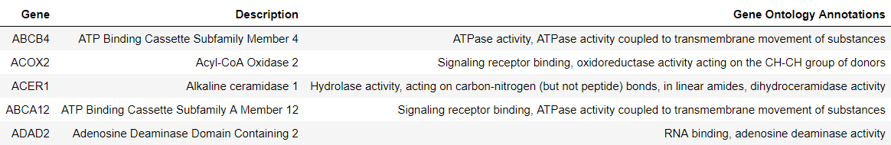

***Table 1.2:*** *Top five highest weighted genes of the cortex dataset across the two principal components with the largest explained variance.17*

In **figure 1.7** we have again mapped the highest weight gene onto the subject’s brain. As compared to **figure 1.5**, there is a lot more differential expression of ABCB4 throughout the cortex than NR2E1 indicating it’s use in regional specificity of gene expression. Instead of only high expression, we see both low and high expression of ABCB4 throughout the cortex suggesting the transporter it encodes is not utilized equally throughout the brain.

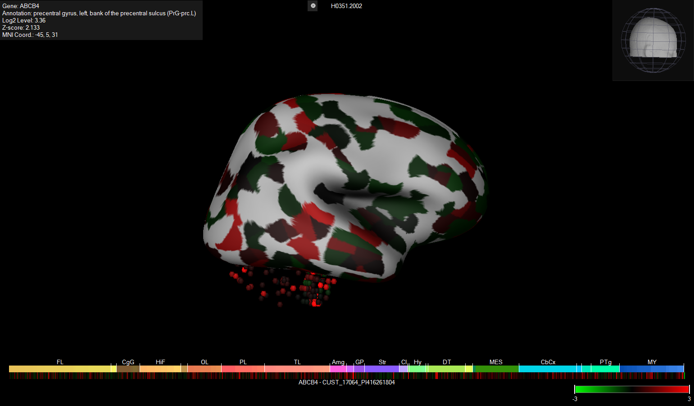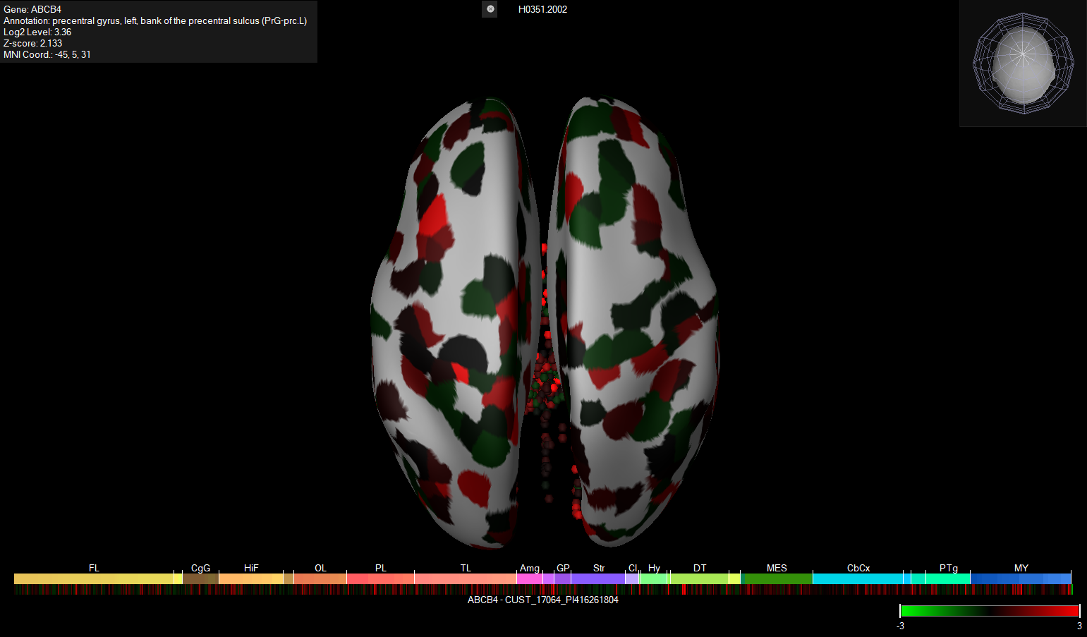

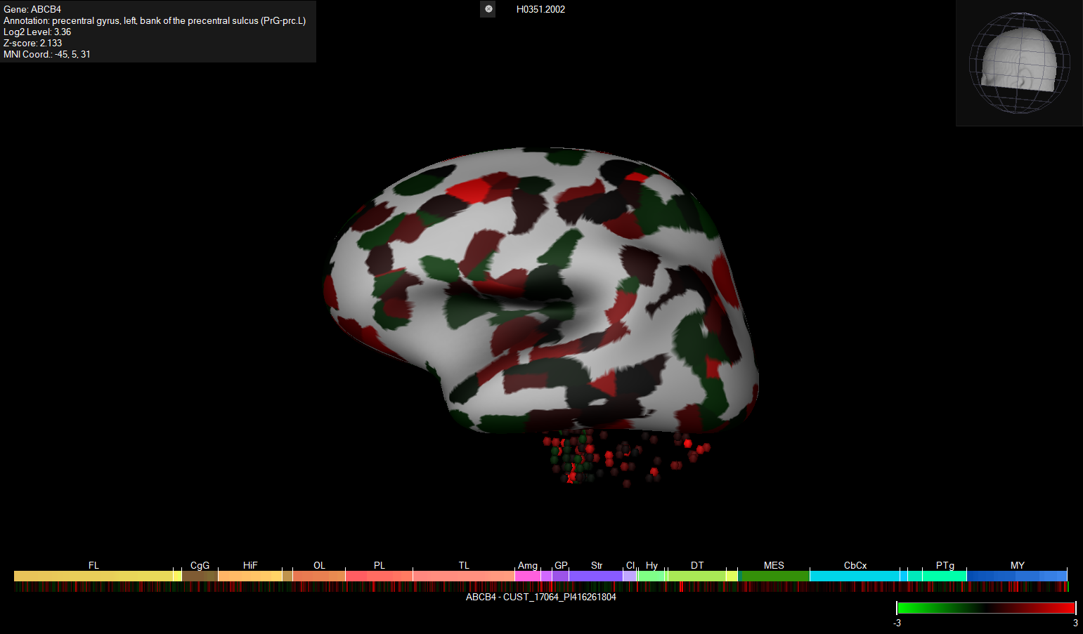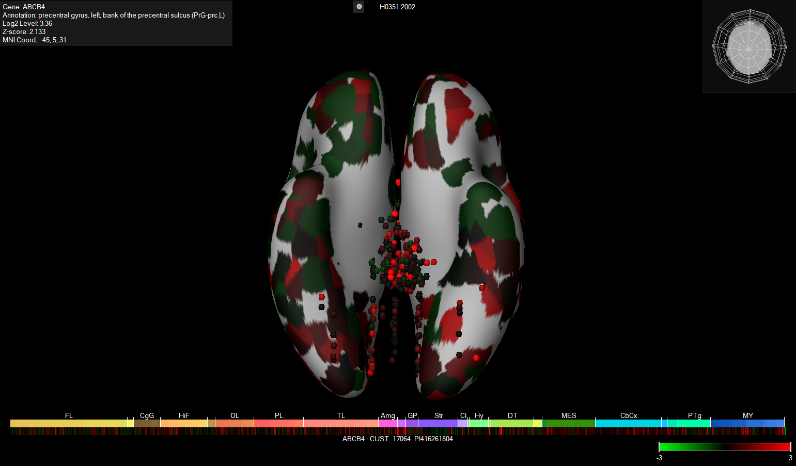

***Fig 1.7:*** *Mapping of the top weighted cortex gene expression data (ABCB4) onto subject’s brain using Brain Explorer 2.*

Overall, the samples seem to cluster particularly well into the three main brain regions of cerebellum, brainstem, and cortex. From this analysis of both the full dataset and just the cortex, we are able to obtain interesting information about specific gene expression throughout the brain, further motivation deeper looks into region specific expression of those genes. Cell specific PCA may lead to more separation at higher resolution both over the full dataset and within the cortex specifically, so it would be of particular interest to apply these methods once more high-throughput, single cell gene expression data can be obtained.

**1.2.3. Clustering**

Next, we performed clustering with K-means, DBSCAN, and agglomerative hierarchical clustering, and used various k values when appropriate. We then assessed the results with a table of various measures and observed how well the clusters line up with sample ontologies.

The k values were chosen such that the first two elements give large scale clusters (k = 3, k = 5) and the following three elements would allow clusters to potentially match up exactly with types of structures (k = 10 [main structures], k = 29 [substructures], k = 82 [detailed structures]). For agglomerative clustering, we chose to use complete linkage, in which sets are joined if they have the minimum *maximum* distance between points. This gives the most compact clusters, which should provide a relatively unique clustering compared to the other methods. It may also be more informative about where a drug would be likely to end up in our transporter study because compact clusters are highly similar.

DBSCAN relies on density, which suffers from scale issues at high dimensions, especially in our case where the dataset is very sparse. We therefore use the top 5 principal components instead of the actual dataset, and selected values for 'eps' (maximum distance to be considered neighbors) and 'min_samples' (number of samples needed for a region to be considered dense) such that the number of components is 5, allowing comparison with the other methods.

As shown in **figure 1.8**, The data does not cluster as well as we expected. For example, the PCA plots for k = 3 appear to have a natural separation between the cerebral cortex (exterior of brain, bottom right of plot), deep brain (top of plot), and subcortex (majority of samples, left), but neither K-means nor agglomerative clustering recapitulated this separation. This is partly because of the high dimensionality of the dataset (many principal components are needed to explain the variance) and its sparsity. It is especially surprising that K-means clustered deep and exterior regions of the brain together in this run.

As we increase K through 5 and 10, we see separations that look somewhat like the 'Main Structure' ontology. The two-dimensional PC plots certainly do not capture the full story (again, due to the high dimensionality of the dataset). We can see groups that include elements of the deep brain and subcortex that look somewhat linear and parallel in these biplots, which would likely separate much better in higher dimensions. High K is difficult to interpret from these biplots but may be informative in the next visualization.

DBSCAN does not work well with this dataset, even after the dimensionality reduction we performed. Many points were marked as outliers, but parts of the subcortex were grouped similarly to other methods.

*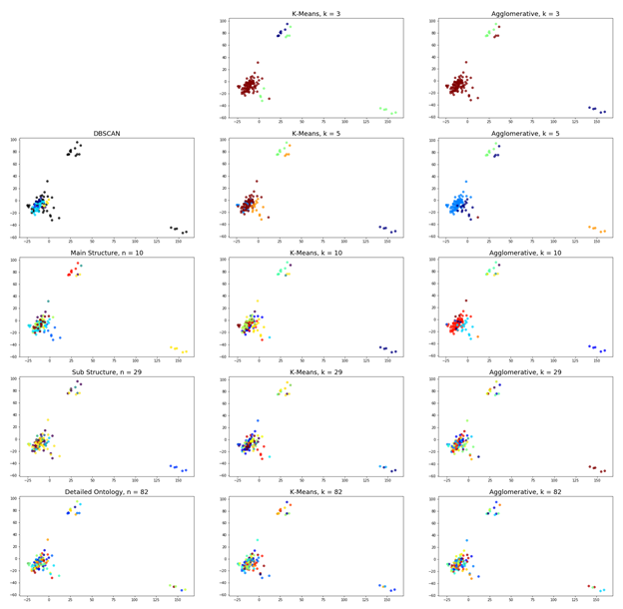****Fig 1.8:*** *Cluster biplots. The x and y axes are the first and second principal components, and different colors indicate different groupings. The letter ‘n’ replaces ‘k’ in the titles of biplots which correspond to actual structural groupings in the data (lower left). In DBSCAN, black indicates outlier samples. The clusters fail to match structure labels and visual separations in the data.*

**Table 1.3** shows the performance of clusters by various metrics. We chose the metrics in the table because they inform each cluster method's applicability to the drug transporter study (section 3). Cohesion (sum of squares within clusters) is a measure of closeness within clusters, which may suggest how homogeneously a drug targeting that cluster would distribute within it. Of course, clusters are more cohesive as K increases, with algorithmically derived labels always being more cohesive than their structure-label counterparts. K-means was slightly more cohesive than agglomerative clustering at low k, which is a result of the K-means centroid method directly aiming to reduce this measure.

Separation (sum of squares between clusters) may suggest how well drugs could discriminate between these clusters. Clusters were more separate as K increased.

The F-Ratio (SSB/SSW) provides a more general score combining the previous measures, and shows how significantly increasing the K can improve cohesion and separation for this sparse dataset. This measure shows that DBSCAN (which found k = 5) performs nearly as well as k = 29 from other methods, but keep in mind that outliers were removed so this value is artificially inflated.

None of the above metrics penalize overfitting, so we included AIC, the Akaike information criterion, to penalize cluster number. By this metric, agglomerative clustering with low k is the best.

Mean silhouette coefficient is a good measure of how well the average point in each clustering fits with its cluster. It gives DBSCAN a negative score because of its many outliers. It also gives a negative score for the sub structure and detailed ontology labels, which indicates that transcription is not well explained by these categories. Silhouette coefficients generally trend down as k increases, meaning that the clusters are overall more mixed.

Combined, these metrics show that typical clustering algorithm performance on this dataset is highly dependent on choice of k and may not be very generalizable due to the sparsity and high dimensionality of the dataset, but that certain structures (particularly the subcortical structures in DBSCAN and k = 5-10) are fairly homogeneous and easily found.

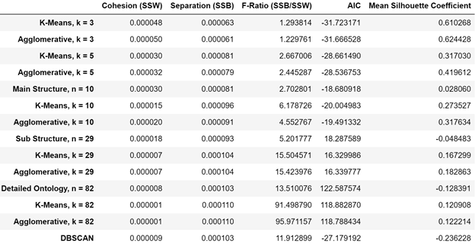

***Table 1.3:*** *Performance of groupings by various metrics.*

In **figure 1.9**, we analyzed how well clusters align with structural groups when k = n. In k = 10, we can see that agglomerative clustering better recapitulated main structures than K-Means because the matrix is sparser and non-zero elements are darker. Half of the structures were kept together by the clustering, but cluster zero contained 3 of those structures and fractions of others, which are indistinguishable structures of the cortex. K-Means was able to keep three structures together, and it placed each of them in their own cluster. The substructures in k = 29 were surprisingly harder to keep together, as indicated by the generally lighter colors in the matrices of the second row - only one substructure was fully contained within a cluster for both algorithms, and it was a different structure for both. Detailed ontology (k = 82) has many more groups kept together, which is to be expected since there are few samples in each one and they should be from very similar brain regions. However, there are still many examples of clustering splitting up the ontologies.

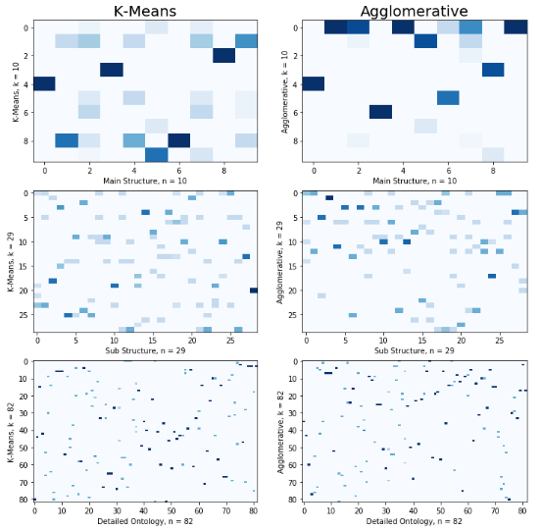

***Fig 1.9:*** *Overlap between structures and clusters. These plots place clusters along the vertical axis and structures along the horizontal axis and populates each space with a color such that dark blue indicates that the given cluster contains all samples within the structure, and lighter blues indicate fractions of structure samples. Many clusters separate structural elements, even at high resolution*

This inconsistency may pose a challenge for drawing conclusions about transporter expression in similar brain regions. It agrees with our earlier observation that substructures do not predict RNA concentrations very well. Perhaps there is a better sample labeling technique (for example, by function of the brain region) that is more conserved by these clustering methods. The poor clustering performance motivates our supervised learning approach in the following section, which should better explain gene expression by using knowledge of structures.

**2. Supervised Learning**

**2.1. Class Analysis**

The goal of this section was to look at how well various models could differentiate between brain regions using gene expression data. Multiple different resolutions were identified in the RNA-Seq dataset as well as by PCA. Ideally, we would be able to train a classifier at the highest resolution, but because of the limited number of samples, there is a natural trade-off between resolution of brain region size and accuracy of a classifier. We would like to select the optimal resolution to obtain an accurate classifier while still finding useful information on gene expression location in the brain.

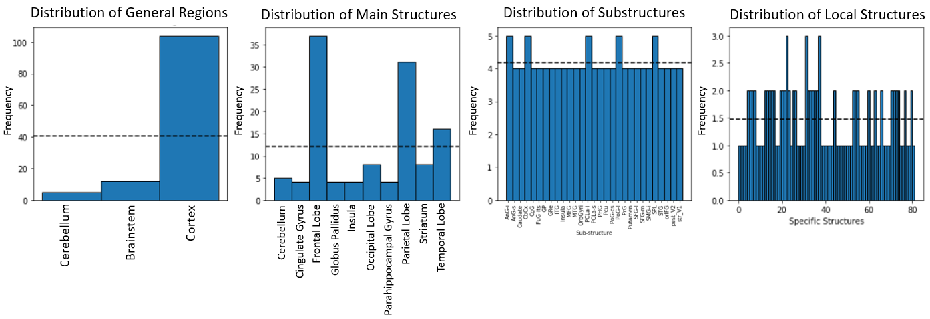

***Fig 2.1:*** *Distribution between sample classes at increasing resolutions. In all cases, classes were unbalanced. As highlighted in the leftmost figure, the majority of samples came from the cortex. Within the cortex, samples mostly came from the frontal lobe, parietal lobe, then the temporal lobe.*

The resolution-sample distribution is displayed in **figure 2.1**. At the lowest resolution, we are solely looking at 3 regions: the cortex, cerebellum, and brainstem. This was chosen because of how well the samples clustered into these three regions in PCA. The next resolution was ‘Main Structures’, reflected by the labels in the dataset. This resolution keeps the cerebellum as one label, splits the brainstem into globus pallidus and striatum, and splits the cortex into 7 regions including the frontal, occipital, temporal, and parietal lobes as well as the insula, parahippocampal gyrus, and cingulate gyrus. After that, we have the substructure resolution which contains 29 different substructures, as was annotated in the dataset. This level of resolution looked at specific gyri and lobules within the cortex and structures of the brainstem such as the caudate and putamen. The cerebellum remained simply labelled as such at this resolution. The highest resolution we looked at had 82 specific structures which added locational and hemispheric information, such as superior or inferior.

As shown above, the classes are unbalanced in all cases, so the classes will be weighted while training each model.

**2.2. Coarse Grain Classifier Training**

First to find the best possible model for our datasets, we trained and tested six different multiclass classifiers across each resolution level and looked at their performance compared to the dataset with the Jaccard similarity score. Supervised learning analysis was implemented using Scikit-Learn, a machine learning software implemented in Python. We used Decision Tree, k-Nearest Neighbors (KNN), Gaussian Naïve Bayes, Multinomial Logistic Regression, and Random Forest classifiers, which are all inherently multiclass. Additionally we used a one-vs-one Support Vector Machine (SVM) classifier. All models were set to a ‘balanced’ class weight except Gaussian Naïve Bayes, which does not currently support this implementation. This is likely the reason for its poor performance. The SVM classifier was also set to a linear kernel to simplify the model creation. The Logistic Regression was set to ‘multinormial’, creating a multiclass classifier. Additionally, the solver was set to ‘lbfgs’, which can handle the multiclass problem in a multinomial manner instead of a one-vs-all scheme. Random Forest was set to 100 estimators as that will be the new default value in the next version of Scikit-Learn. All other settings were left at default for the coarse grain analysis.

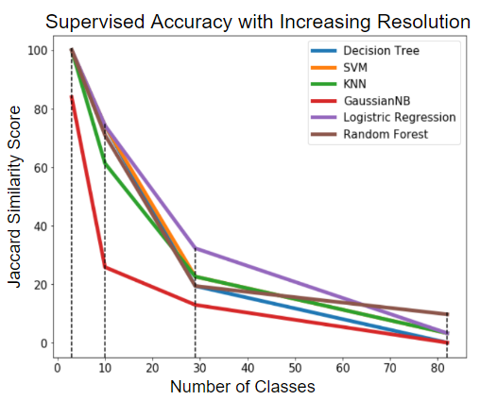

***Fig 2.2:*** *Performance of six different classifiers at each resolution level using labels from the dataset to obtain the Jaccard Similarity Score.*

**Figure 2.2** shows the Jaccard Similarity Score of all six classifiers across the four different resolutions schemes determined from the labels given in the dataset. It is apparent that performance decreases for all classifiers as the resolution increases, as was expected. This behavior is representative of the small number of samples for each class in the higher resolution cases. For example, many structures only have one sample in the 82 class case, as shown in **figure 2.1**. Due to Gaussian Naïve Bayes being unbalanced, it behaved to worst requiring further undersampling of the majority classes or oversampling of minority classes. Again, due to the lack of samples, and the ability of other classifiers to balance class weights, we will not continue analysis with Gaussian Naïve Bayes. With that being said, this is a good proof of concept of issues associated with overestimation of majority classes in unbalanced datasets, validating our decision to balance the classes in the other five classifiers. At the 3-class resolution, all other classifiers achieve perfect performance. There is a marked decrease moving to the 10-class resolution level. Here KNN performs the worst as compared with the other classifiers. At the 29-class resolution, Logistic Regression performs with the best accuracy, and at the 82-class resolution, Random Forest performs the best. In order to try to get useful information at all resolutions, we will continue with fine tuning of the Logistic Regression and Random Forest classifiers. This also allows for using multiple different regularization strategies, including both Ridge and early stopping strategies.

**2.3. Model Fine Tuning**

For model fine tuning, we included bootstrapping using 100 iterations and an 80/20 train/test split. Additional tuning was added to specific conditions but could not necessarily be generalized. Fine tuning Python code can be found in **Appendix 6.2.1. and 6.2.2.**

**2.3.1. Multinomial Regression**

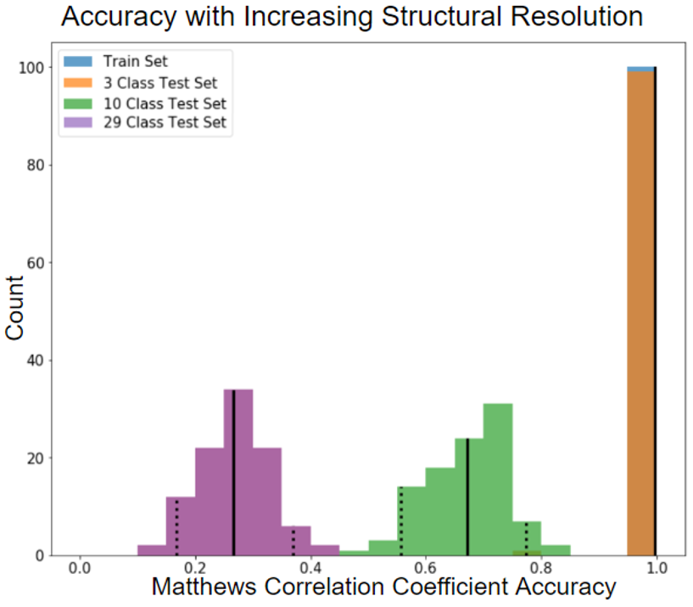

***Fig 2.3:*** *Multinomial Logistic Regression performance measured by the Matthews Correlation Coefficient across the 3-class, 10-class, and 29-class resolutions showing a decrease in performance accuracy as the number of classes increases.*

Multinomial Logistic Regression was run at the 3-class, 10-class, and 29-class resolutions but not at the 82-class resolution due to remarkably low performance obtained without bootstrapping (3.23%). As seen in the coarse classifier training, there was a decrease in performance as the resolution increased (**figure 2.3**). Multinomial Regression performed perfectly at the 3-class resolution level with 95% confidence intervals still obtaining perfect performance. Five-fold cross-validation done 100 iterations was run for this resolution and obtained the same confidence intervals indicating there was not overfitting.

The 10-class resolution performance decreased to an average of 67.13% with 95% confidence intervals of 55.7% to 77.4%. While this performance is not as good as the 3-class level, the model is still able to predict the correct main structure a majority of the time. Accuracy dropped again looking at the 29-class substructure resolution with an average of 26.6% and 95% confidence intervals of 16.8% to 36.9%. The model is still able to achieve a better-than-random accuracy score, which would be approximately 3% for 29 classes. Even the 82-class model performs better-than-random at 3.23% compared to approximately 1%. This suggests there is some useful differential information in the gene expression that could perhaps train a model with more samples. Additionally, single cell gene expression data is likely to perform better than our current dataset. Cross-validation could not be performed for either the 10- or 29-class resolution levels because the there were not enough samples, leading to errors from the least populated classes having fewer samples than the number of splits. All model training was performed with L2, or Ridge, regularization because L1 regularization could not converge.

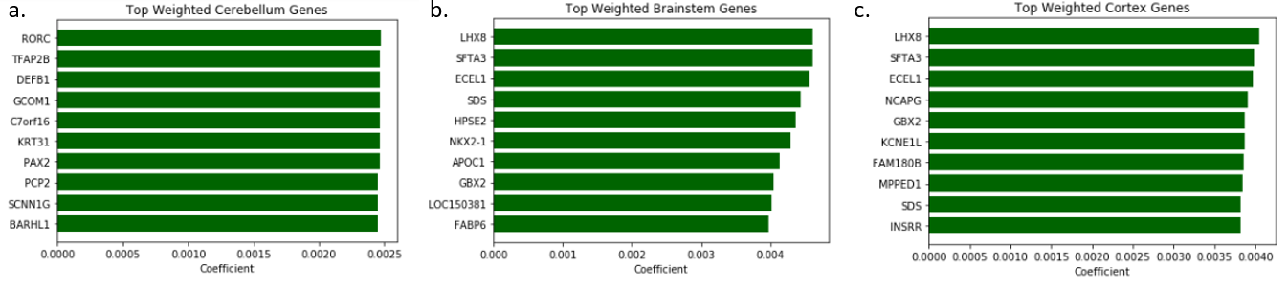

***Fig 2.4:*** *Top 10 highest weighted genes for the cerebellum (a), brainstem (b), and cortex (c) from the 3-class Multinomial Regression model.*

**Figure 2.4** shows the coefficients for the top 10 highest weighted genes in the 3-class Multinomial Regression model. The top coefficients are still low, and there is not much change in value from the top gene to the tenth indicating there were are many genes expression values used to create this model, and it cannot be approximated by only a few. This again highlights the complexity of the brain as compared to a single-cell organism. The descriptions and gene ontology annotations can be seen in **table 2.1** for each class. The top 2 genes in the cerebellum encode DNA-binding transcription factors. Similar to PCA for the full dataset, we see the importance of transcription factors in identifying the cerebellum. In this case, though, we see a high expression of the top gene, RORC, as displayed in **figure 2.5** instead of a low relative expression of the highest weighted transcription factor.

Interestingly, the brainstem and cortex share five of the same genes in their list of top ten highest weighted genes: LHX8, SFTA3, ECEL1, SDS, and GBX2. In each case, the cortex coefficient is approximately equal and opposite to the brainstem coefficient. While a gene is being highly expressed in in the brainstem, it is being lowly expressed in the brainstem. This highlights that the vastly different functions of the cortex (high level thinking and reasoning) compared to the brainstem (basic bodily functions) are reflected by differential gene expression.

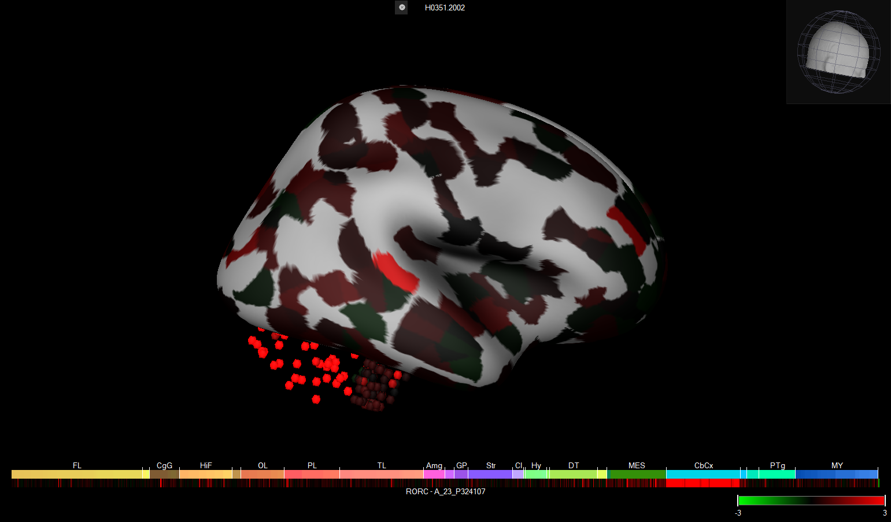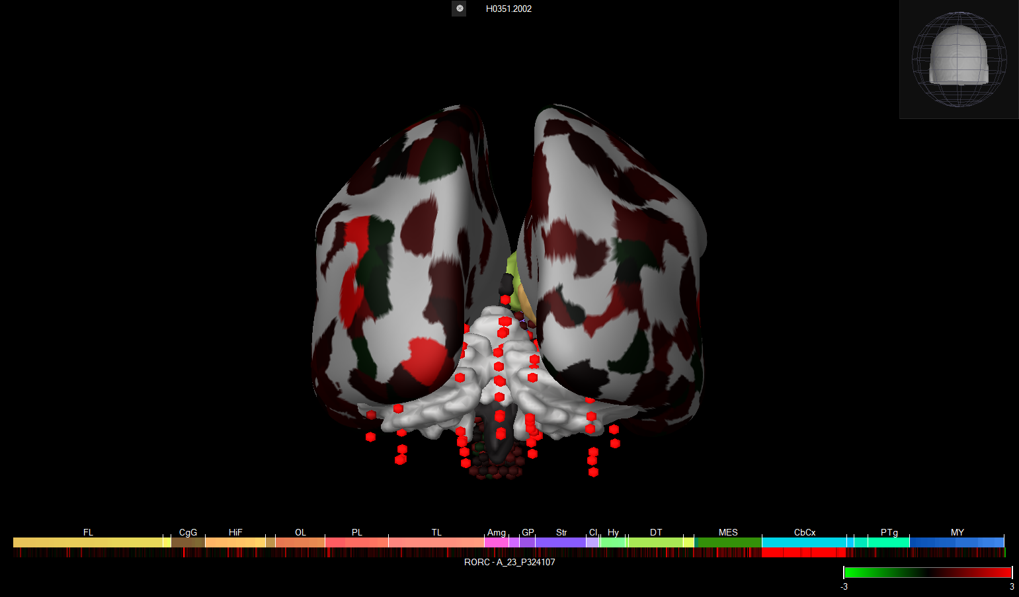

***Fig 2.5:*** *Top weighted gene expression in cerebellum classification, RORC, mapped on the subject’s brain using Brain Explorer 2.*

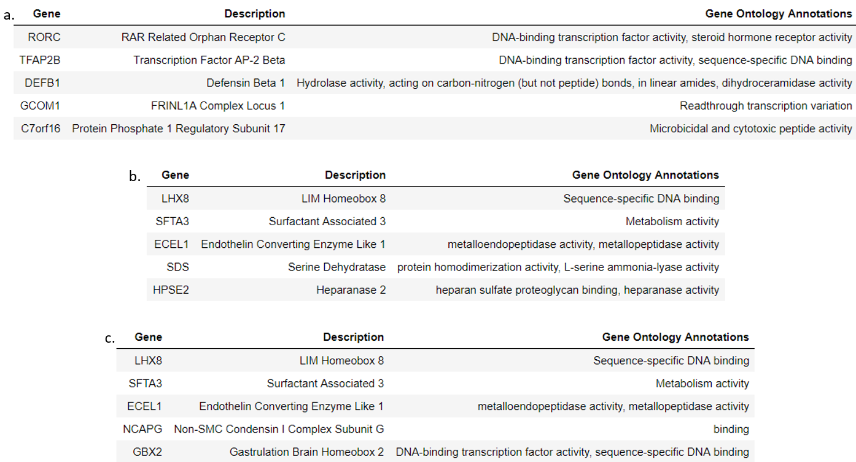

***Table 2.1:*** *Top 10 highest weighted genes for the cerebellum (a), brainstem (b), and cortex (c) from the 3-class Multinomial Regression model.17*

Looking at **figure 2.6**, we see that LHX8 is highly expressed in the brainstem while it is expressed relatively lowly in the cortex. LHX8, or LIM Homeobox 8. LIM-homeobox genes have been conserved through evolution, seen in all organisms studied to data.20,21 Similarly, the brainstem is the oldest and most conserved aspect of the human brain evolutionarily speaking and is also found in most living animals, suggesting LHX8’s function in neural patterning is one used to maintain basic bodily functions rather than higher level thinking.22

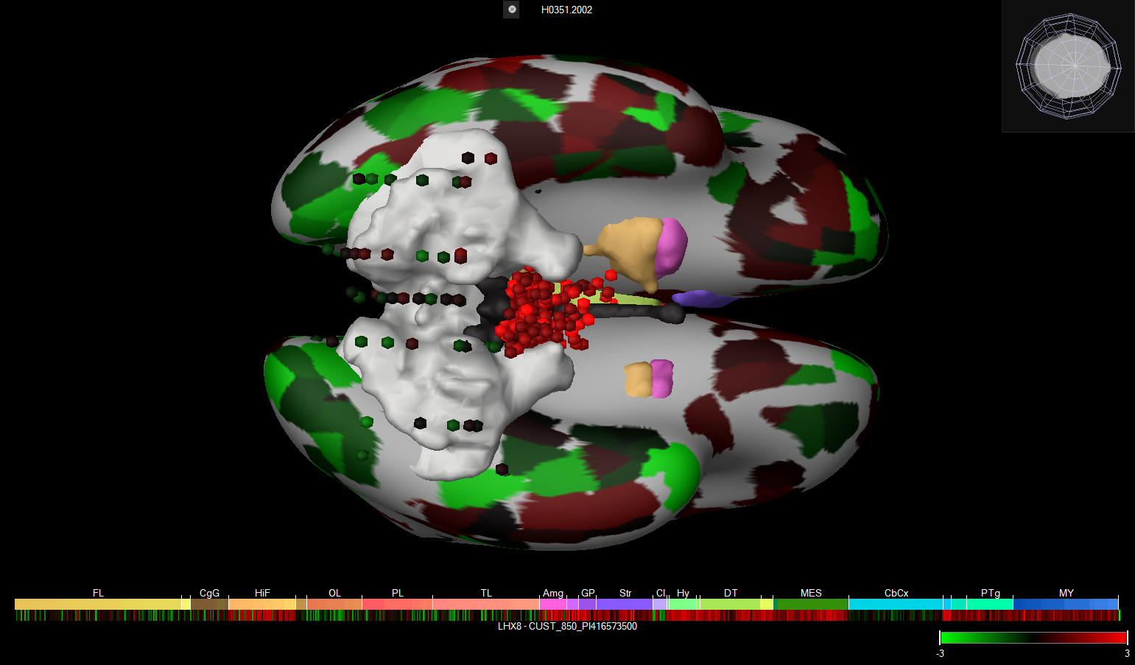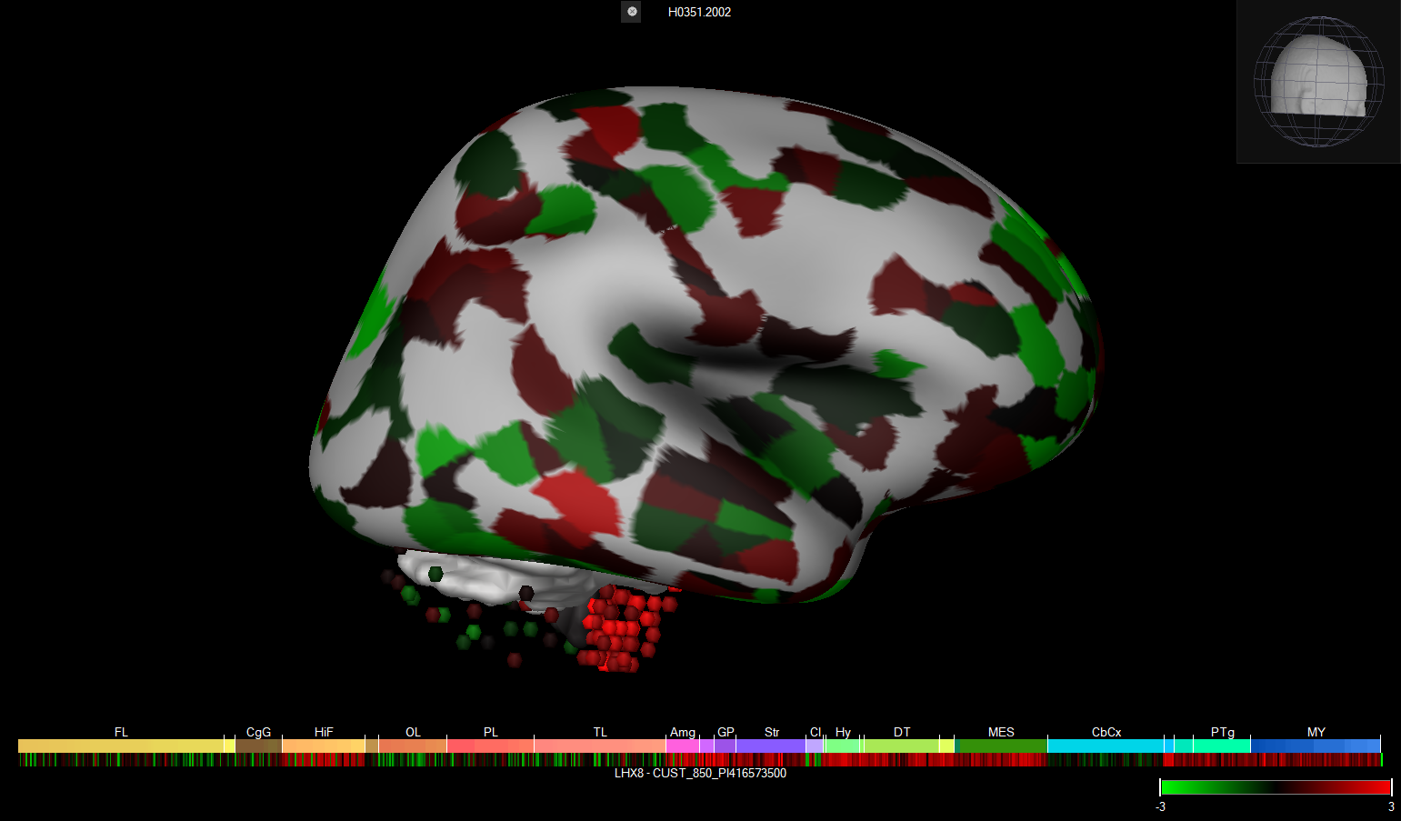

***Fig 2.6:*** *Top weighted gene expression in brainstem and cortex classification, LHX8, mapped on the subject’s brain using Brain Explorer 2.*

It has been shown that changes in the deep brain, specifically in the dorsal anterior cingulate cortex and the insula, has been associated with multiple brain disorders including schizophrenia, bipolar disorder, depression, and addiction.23 Thus it is of particular interest to look at gene expression information in these areas. Similar analysis can be done for other top genes or for the top genes at the other resolution levels but will not be included here. The top ten genes for each of the ten main structures and their coefficients is included as **Appendix 6.2.3**.

**2.3.2. Random Forest**

Random Forest was selected because it worked particularly well at higher resolution as compared to the other classifiers. We also refined the model by bootstrapping it with 100 iterations and an 80/20 train to test split. As with multinomial regression, accuracy was assessed using a Matthews Correlation Coefficient. Because of its higher accuracy at the 82-class resolution, a Random Forest model was built at all resolution levels. At the 3-class resolution level, the Random Forest model had an average accuracy of 98.7% with 95% confidence intervals of 74.5% to 100%. Thus, the Random Forest classifier performed worse than the Multinomial Regression at this resolution, likely due to the stochastic nature of Random Forest models. At the 10-class resolution, the average testing accuracy was 65.1% with 95% confidence intervals of 47.5% to 76.8%, making it slightly worse than the Multinomial Regression at this resolution, but not by much. Going to the 29-class resolution, the accuracy again drops to 24.0% with 95% confidence interval of 13.2% and 35.5%, again slightly worse than the Multinomial Regressor. For the 82-class case, the Random Forest model performed with an accuracy of 5.3% and 95% confidence intervals of 1.2% to 10.9%. At this resolution, the Random Forest performs better than the Multinomial Regression model, but the performance is still very poor. At all other resolutions, the accuracy is comparable across the two models.

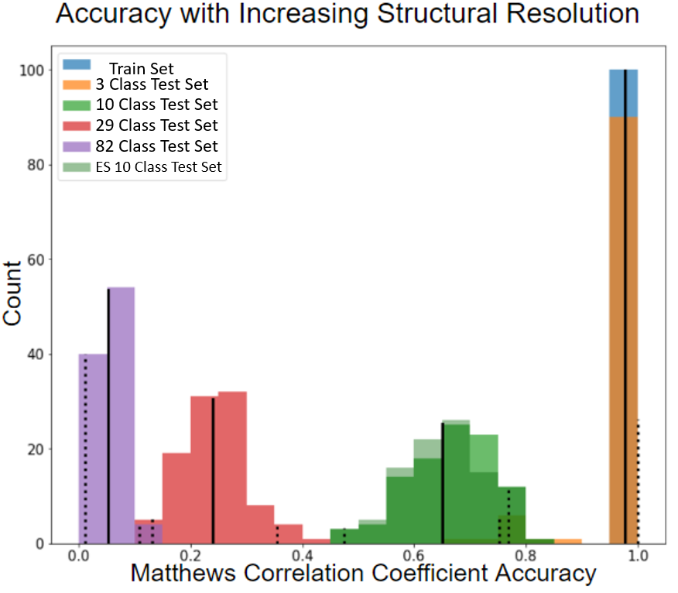

***Fig 2.7:*** *Random Forest model performance measured by the Matthews Correlation Coefficient across the 3-class, 10-class, 29-class, and 82-class resolutions showing a decrease in performance accuracy as the number of classes increases.*

In the previous models, the Random Forest was allowed to run without a specified maximum tree depth, but upon looking into early stopping regularization, the trees were able to be stopped early while still maintaining performance.

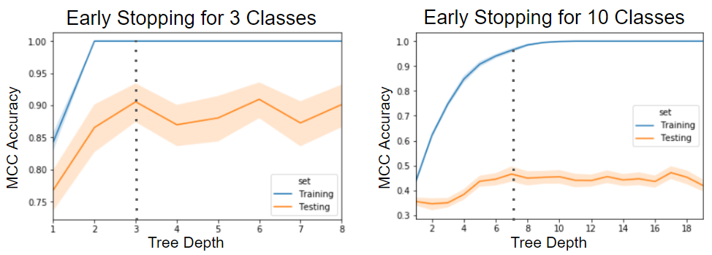

***Fig 2.8:*** *Trade-off between training and testing accuracy allowing for early stopping at the 3-class and 10-class resolutions.*

For the 3-class resolution case, the training set performance increases to perfect by depth 2 (**figure 2.8** left). Testing set performance appears only to increase by depth 3, then plateaus (it is likely that the problem is perfectly solvable by depth 3, hence why there aren't any performance dynamics past that depth). The optimal depth appears to be 2-3. For the 10-class resolution, training set performance increases to perfect by depth ~10 (**figure 2.8** right). Testing set performance appears to increase by depth 8, then plateaus. The optimal depth appears to be 6-7. A bootstrapped Random Forest model was tested and trained again with a maximum depth set to 6, and still maintained approximately the same performance (**figure 2.7**) with a training accuracy of 99.9% and an average testing accuracy of 65.4% and 95% confidence intervals of 49.7% to 78.7%.

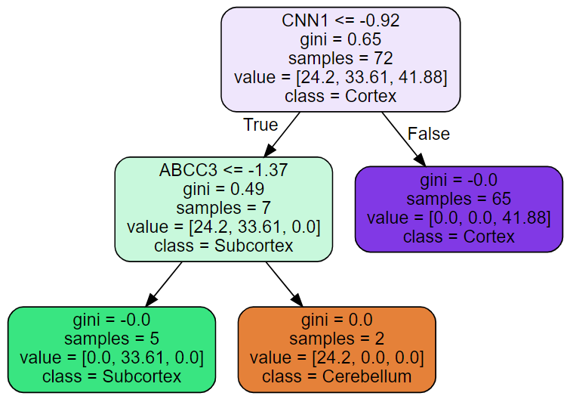

***Fig 2.9:*** *Sample tree for the 3-class resolution Random Forest model.*

In **figure 2.9**, we see a sample tree for the 3-class resolution Random Forest model. Innate in Random Forest, we obtain entirely different genes of top importance every time it is run and for every tree while Multinomial Regression obtains the same list of genes. For example, running this model 10 different times obtained 10 different lists of the top 10 weighted genes based on feature importance. Therefore, the random nature of Random Forest adds another layer of difficulty to gene assessment.

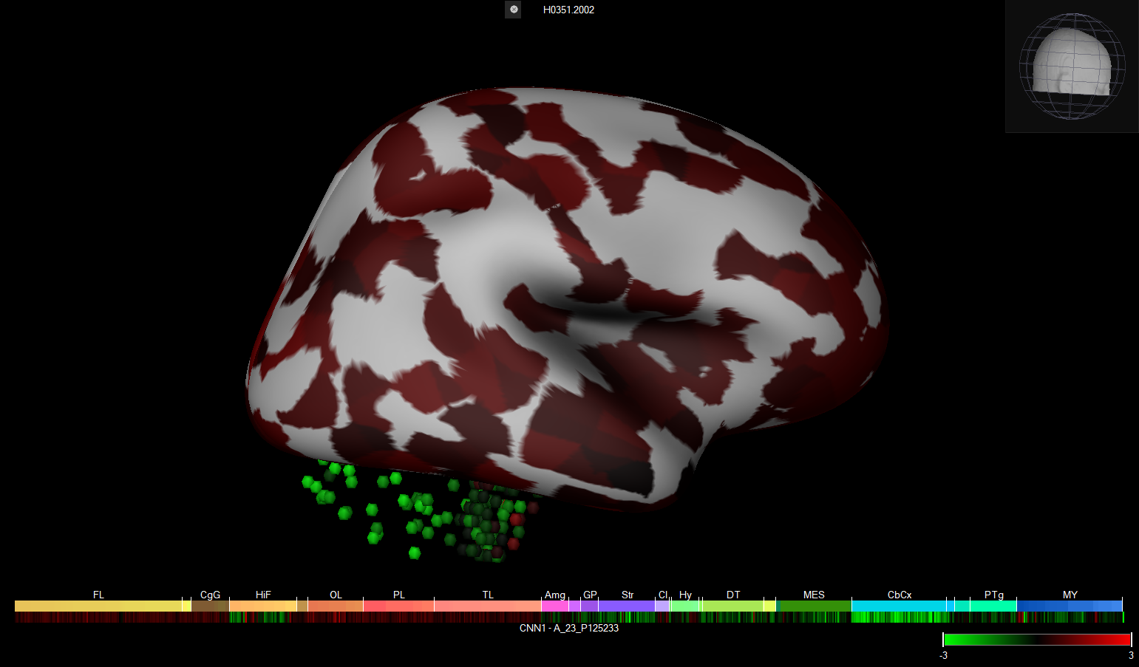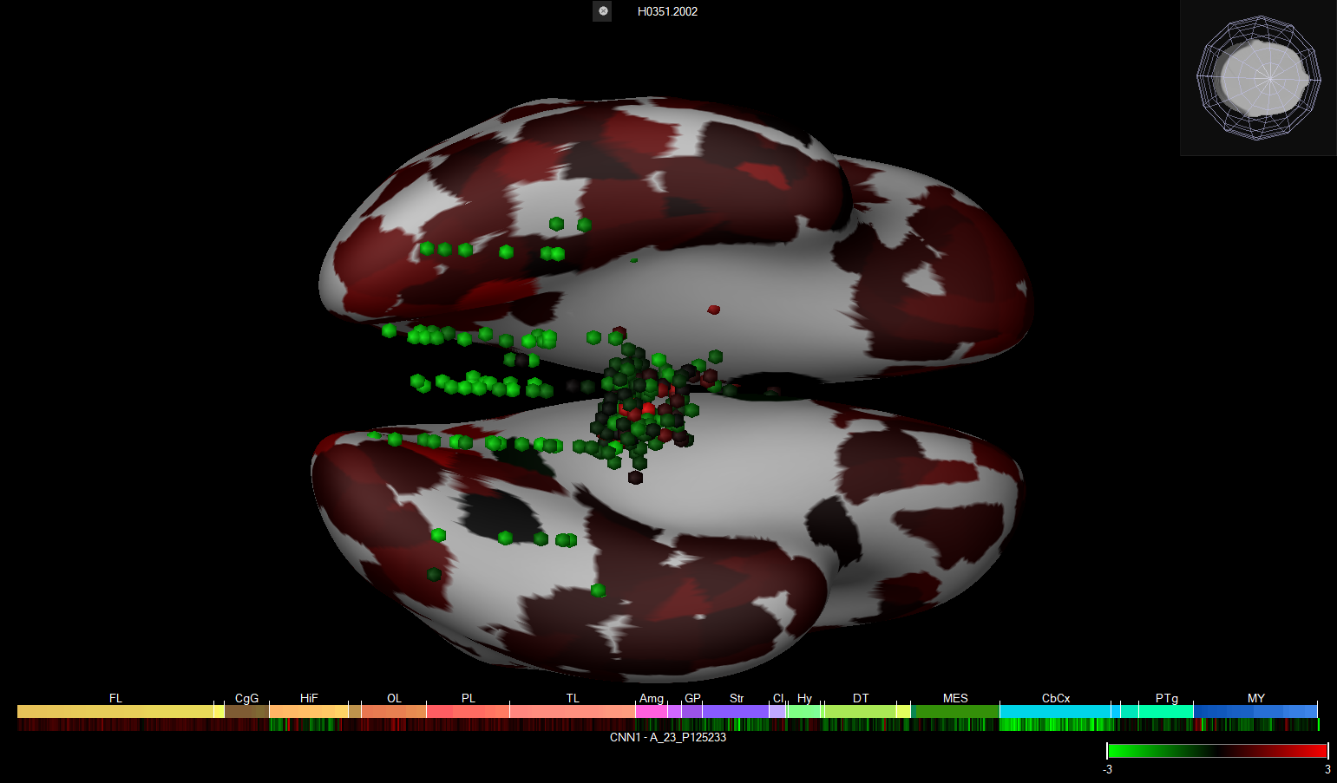

***Fig 2.10:*** *Top weighted gene expression, CNN1, in sample tree for Random Forest model at cortical decision node.*

**Figure 2.10** displays the gene CNN1 used at the cortex decision node in our sample tree from **figure 2.9**. We see relatively high expression of CNN1 in the cortex compared to both the cerebellum and the brainstem, although the brainstem does appear to have some higher expression of CNN1 than the cerebellum. CNN1, or Calponin 1, encodes a thin filament-associated protein implicated in the regulation and modulation of smooth muscle contraction capable of binding to actin, calmodulin, troponin C, and tropomyosin.17 This suggests the presence of smooth muscle cells in the cortex and a relatively lack of smooth muscle cells in the cerebellum and brainstem. This provides and interesting example of the use of gene expression data to help answer cell type questions in relation to the brain.

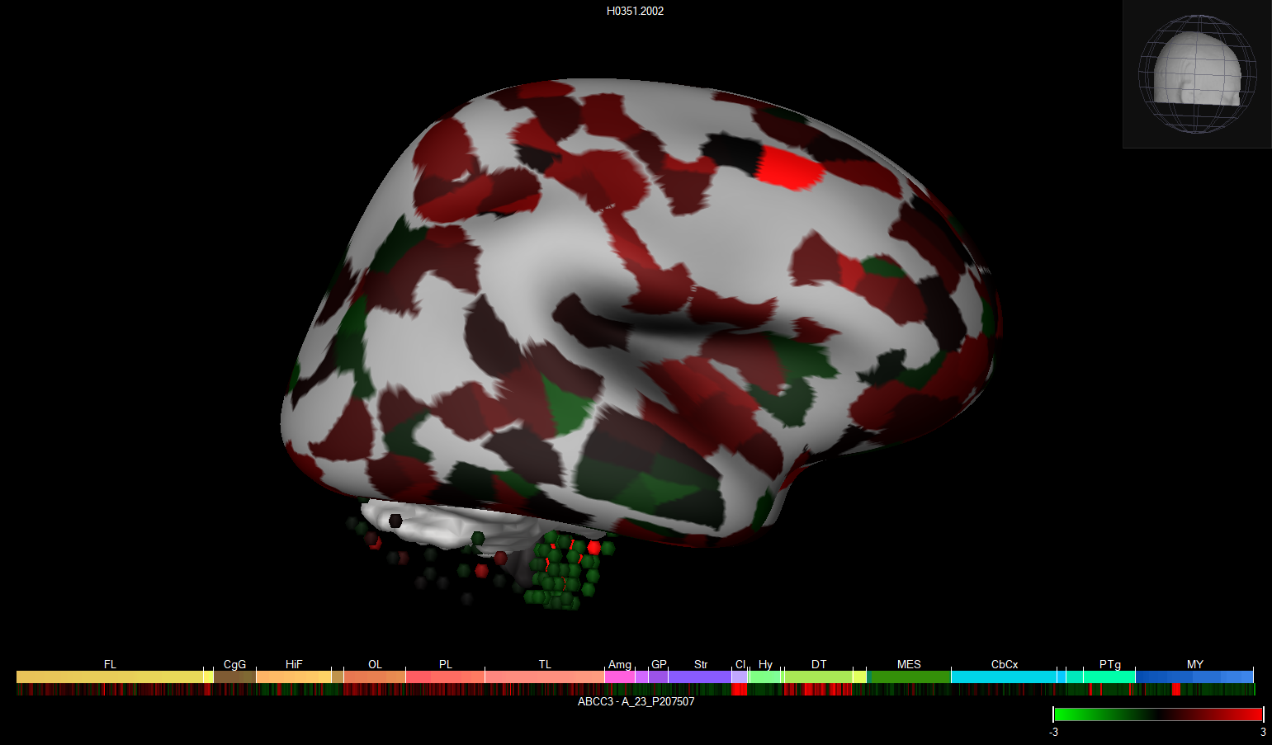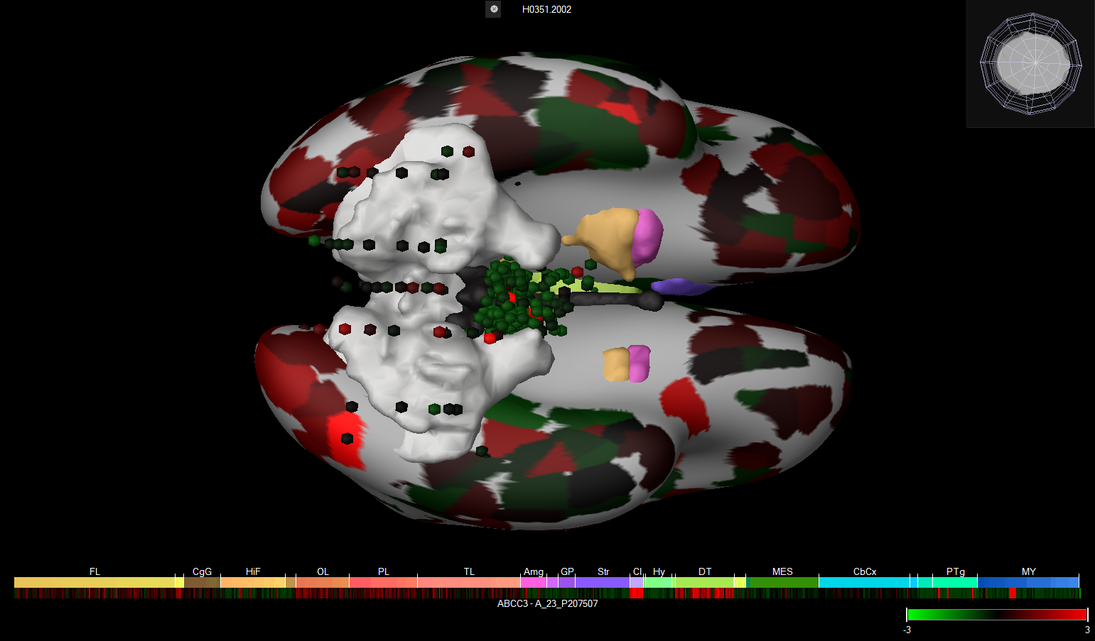

***Fig 2.11:*** *Top weighted gene expression, ABCC3, in sample tree for Random Forest model at brainstem or cerebellum decision node.*

**Figure 2.11** shows the top weighted gene at the decision node between brainstem or cerebellum. ABCC3, ATP Binding Cassette Subfamily C Member 3, shows apparent low gene expression in the brainstem and average in the cerebellum. Again, we see a member of the ATP-Binding Cassette family determining important regional information. This sort of nodal analysis provides interesting information directly comparing two brain regions. Sample trees at the 10-class and regularized 10-class are provided in **Appendix 6.2.4.**

Overall, we see similar performance in both models, but each allows us to answer a different sort of question. The Multinomial Regression model allows gene-wise analysis of specific regions while the Random Forest model allows direct comparison between regions. Additionally, the Multinomial Regression model directly solves the model to create a list of coefficients for each gene, while the Random Forest model creates a stochastic comparison entirely avoiding overfitting, but also changing which specific genes are most valuable at each decision node. Both models do not perform well at high resolutions but do obtain quite a lot of useful biological information at the 3- and 10-class resolutions. Similar approaches would be interesting to apply to single cell variation data.

**3. Drug Transport**

**3.1. Background**

In the past ten years, there has been a paradigm shift in our understanding of cellular uptake of exogenous small molecule drugs. Before that time, studies found that lipophilic and amphipathic drugs were most likely to be taken up by cells, and a ‘rule of 5’ was proposed which listed 5 criteria for lipophilicity (such as an upper bound on hydrogen bond donor sites) that was meant to predict whether or not a drug can diffuse through the plasma membrane. **Figure 3.1a** illustrates this mode of transport. The work of Dr. Douglas Kell and others has refuted this argument, presenting substantial evidence that drugs actually pass through specific transporters for metabolites that are structurally similar to them, as in **figures 3.1b and c** [8]. He suggests a new ‘rule of 0.5’, in reference to a 50% threshold for the similarity measure between the drug and a known transported metabolite (see section 3.2.5).

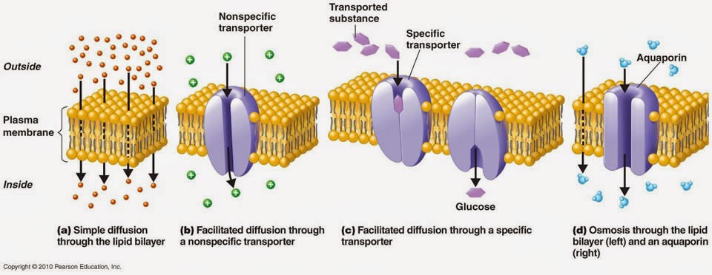

***Figure 3.1:*** *Cellular uptake methods. Previous hypotheses argued that the majority of uptake was through diffusion (a), while current theory places emphasis on (b) and (c) as more likely routes of uptake.*

If this hypothesis is correct and there is sufficient transporter heterogeneity in target tissues, then it would be possible to predict drug uptake by tissue location, which is our goal for this portion of the project. The brain is an especially desirable organ for this because of the large variation in function between adjacent regions of the same organ. Some examples of location-specific brain diseases are shown in **figure 3.2**. A drug attempting to treat a highly localized disease could theoretically be screened with this approach and off-target effects could be predicted based on other sites that it localizes to.

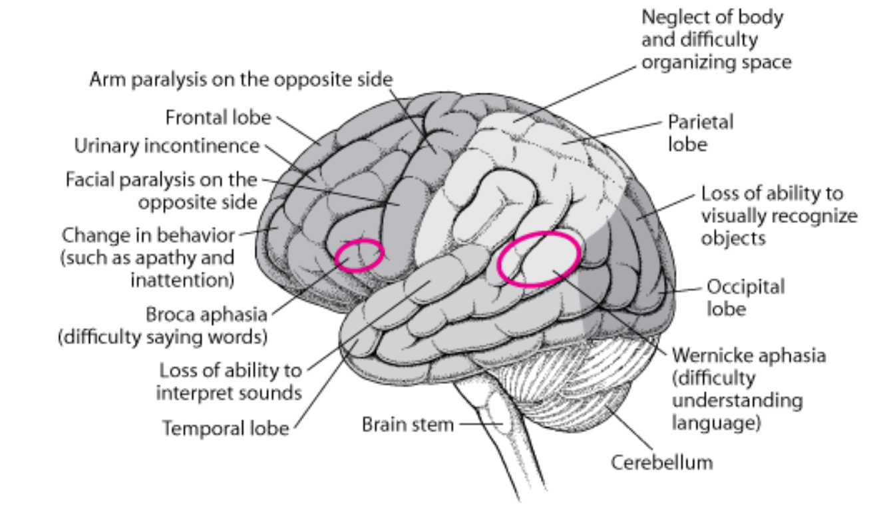

***Figure 3.2:*** *Brain anatomy and examples of location specific dysfunctions. The analysis described herein would inform treatment of these dysfunctions by predicting drug uptake by brain structure.*

The goal of section 3 is to provide a proof of concept for this type of analysis, using only transcriptomics data, a transporter/metabolite database (RECON3D [11]), and a drug database (DrugBank [10]). We will demonstrate how a novel prediction measure of drug uptake – the **T**ransport **A**ctivity/**D**rug **S**imilarity **I**ndex, or TADSI – can be computed from these datasets. We will then perform preliminary analysis of the computed TADSIs with respect to heterogeneity in uptake by brain region and drugs predicted to be taken up. See **figure 3.3** for a detailed schematic of the workflow applied.

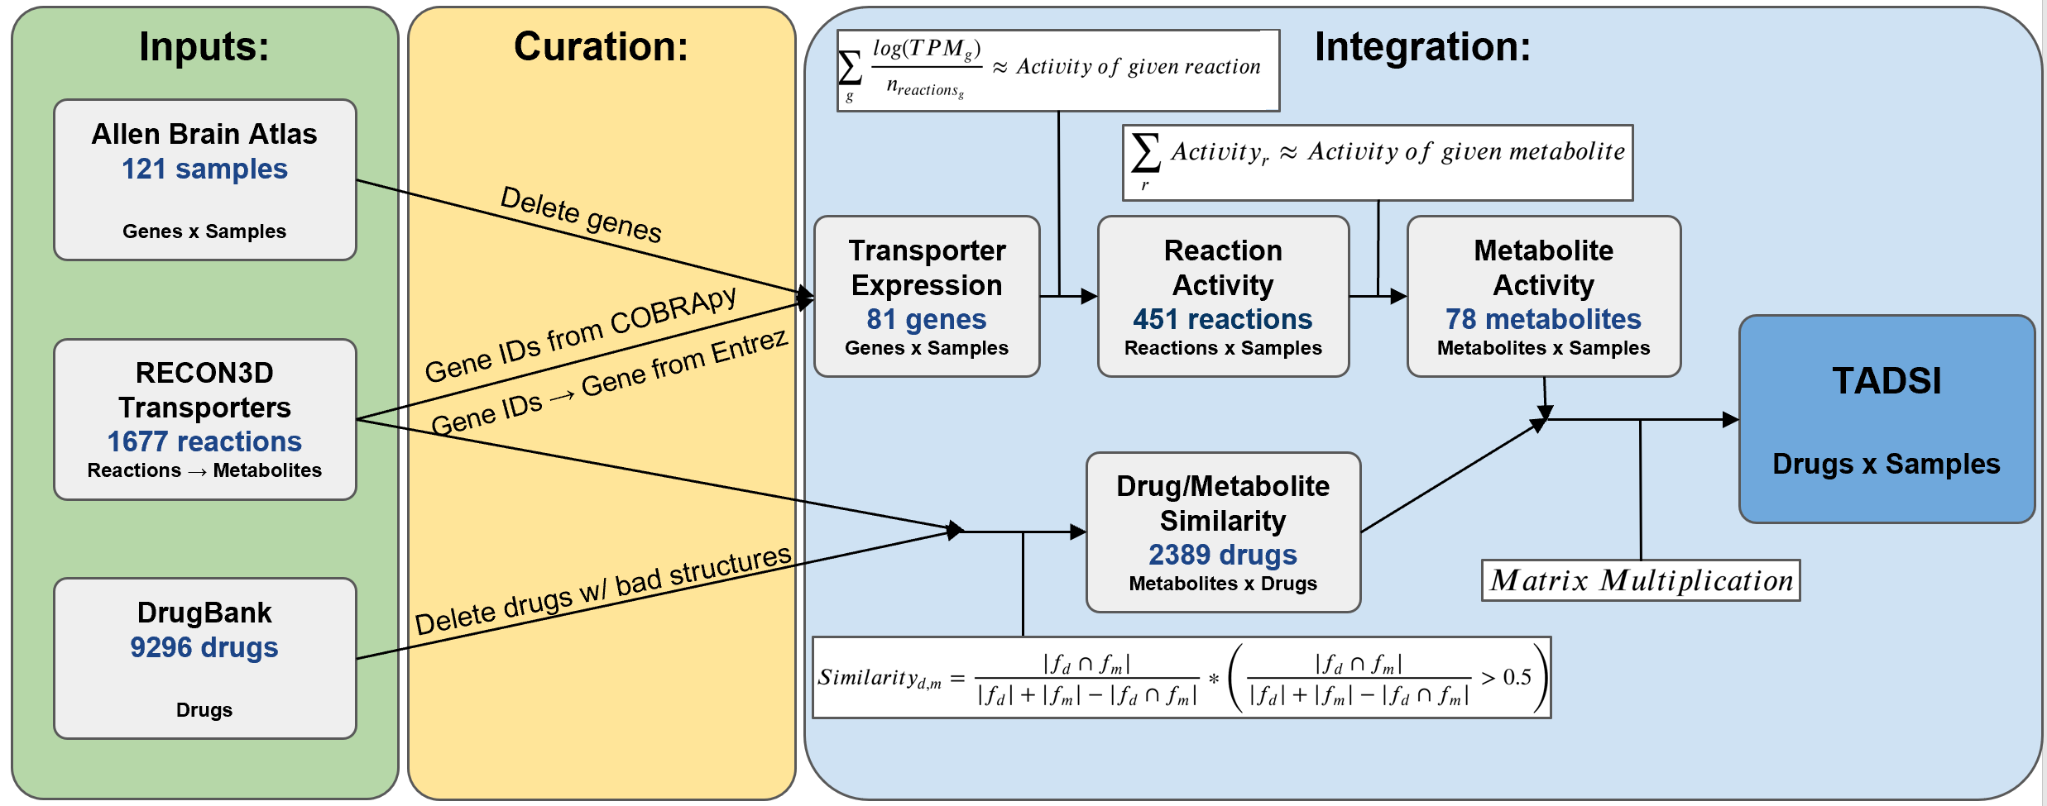

***Figure 3.3:*** *Detailed workflow of drug transport study. The first part of the workflow focuses on obtaining metabolite activities from gene expression data and the transport database, and the second part obtains drug/metabolite similarities. These matrices are multiplied together to obtain the TADSI matrix.*

**3.2. Detailed Workflow**

**3.2.1. Transporter Reactions and Genes Data Curation**

First, disparate datasets were combined. A file containing transport reactions from RECON3D, a human metabolome reconstruction, was obtained from Dr. Dan Zielinski in the Palsson Lab at UCSD.11 Any metabolites without structural data were removed, giving a total of 1677 transport reactions (unique metabolite and transport stoichiometries).

Each reaction had a reaction ID, which could be looked up using COBRApy tools in the RECON3D database.17 Any gene that coded for a protein that could carry out this reaction was returned as an Entrez numerical ID.

Since the Allen Brain Atlas uses character names instead of numerical ones for genes, it was necessary to use the Biopython Entrez lookup tools to convert numerical IDs into descriptive character ones.13 At this stage, 4 names had mismatches with the Allen Brain Atlas, so those were manually looked up on NCBI and changed so that all datasets agreed.

The final transporter gene list came out to 81 after removing all non-transporter genes from the Allen Brain Atlas and removing all genes with bad expression data (see section 1.2.1) from the transporter list. See **Appendix 3.1** for python code for this section.

**3.2.2. Transporter Gene Set**

The gene total dropped from 7,530 genes to 81 genes, which could potentially dramatically alter the sample relationships or reduce interesting heterogeneity in the dataset. To confirm that this was not the case, we performed PCA and tSNE on the dataset as shown in **figure 3.4**. The biplot had the same structure as the full dataset, with three main parts of the brain in clusters, which indicates that the meaningful variance in the data was maintained. The dimensionality of the dataset dropped substantially, which is to be expected since dimensions were directly removed: it now requires 34 PCs to explain 90% of the data, as opposed to 66 PCs for 80% in the full dataset.

The top genes from PCA are also shown in **figure 3.4.** These genes have the maximum combined weight of PCs 1 and 2. Note that they are transporters of common, ubiquitous metabolites for energy and protein production or waste removal as opposed to brain-specific ones. This may suggest that metabolic needs are overshadowing specific functions. Using pieces of brain for RNA-seq instead of single cells is probably causing these functions to appear more strongly in this dataset because of the inclusion of blood and stromal cells as opposed to specifically targeting neurons.

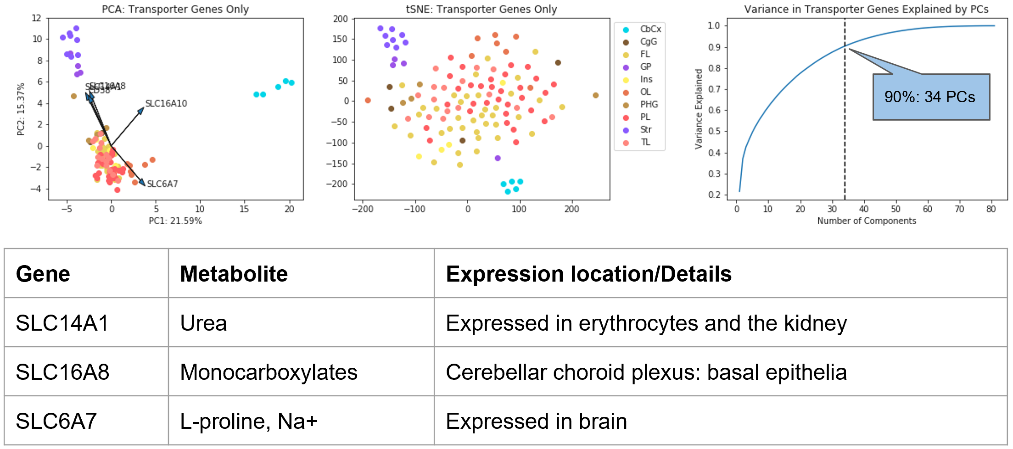

***Figure 3.4:*** *Dimensionality reduction of the transporter gene set. The PCA biplot has similar sample arrangement to the full dataset, indicating that the reduction in dimensionality did not remove important variance. The dimensionality reduction and top genes are illustrated by the cumulative variance plot and table, respectively.*

**3.2.3. Gene:Reaction Mapping**

**Figure 3.5** illustrates the distributions of reactions per gene and genes per reaction in our data. The x axis values above 1 correspond to transporter promiscuity events (there are no transporter complexes that require multiple genes for one reaction in this dataset). Transporter promiscuity is good for drug delivery because it allows chemicals with similar structures into the cells, but it presents a significant modeling problem. Simply summing the gene expression of each gene that contributes to a reaction would correspond to a situation in which a promiscuous transporter with *n* reactions has *n* times as much flux as single-reaction transporters. This would lead to a model that weights the most popular promiscuous metabolites far more than the unique metabolites with pickier transporters, which does not match the biological situation and would therefore provide inaccurate predictions.

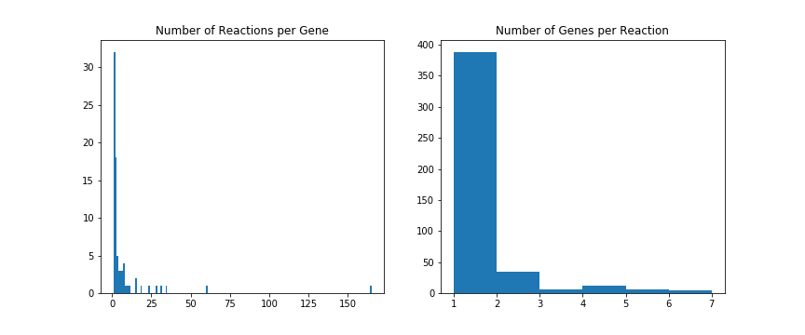

***Figure 3.5:*** *Histograms of reactions per gene and genes per reaction. X axis values above 1 indicate promiscuous transporter events.*

To correct for this, calculate the activity of each reaction as in **equation 3.1**. Each expression value is divided by the number of reactions that gene carries out, which forces each gene’s flux to be proportional only to its expression. Note that we make several assumptions in this analysis:

* Protein-level regulation is ignored because only transcriptomic data is available.
* The flux of each reaction is not available, so we assume that each reaction performed by gene has an equal fraction of its activity.
* The contribution of each gene to a reaction’s flux is additive.

Each of these assumptions could be addressed by future directions that integrate proteomic, fluxomic, kinetic (transport affinities and velocities), and empirical transport data to improve the activity approximation.

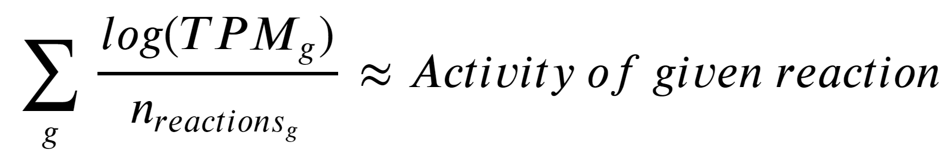 ***(Equation 3.1)***

See **Appendix 3.2** for code that carries out this conversion.

**3.2.4. Metabolite Activities**

Reactions have unique stoichiometries and metabolites, but the stoichiometry doesn’t provide useful information about drug uptake, so we must sum each reaction with matching metabolites to give the metabolite activity in each brain region. Doing so generates the matrix shown in **figure 3.6.**

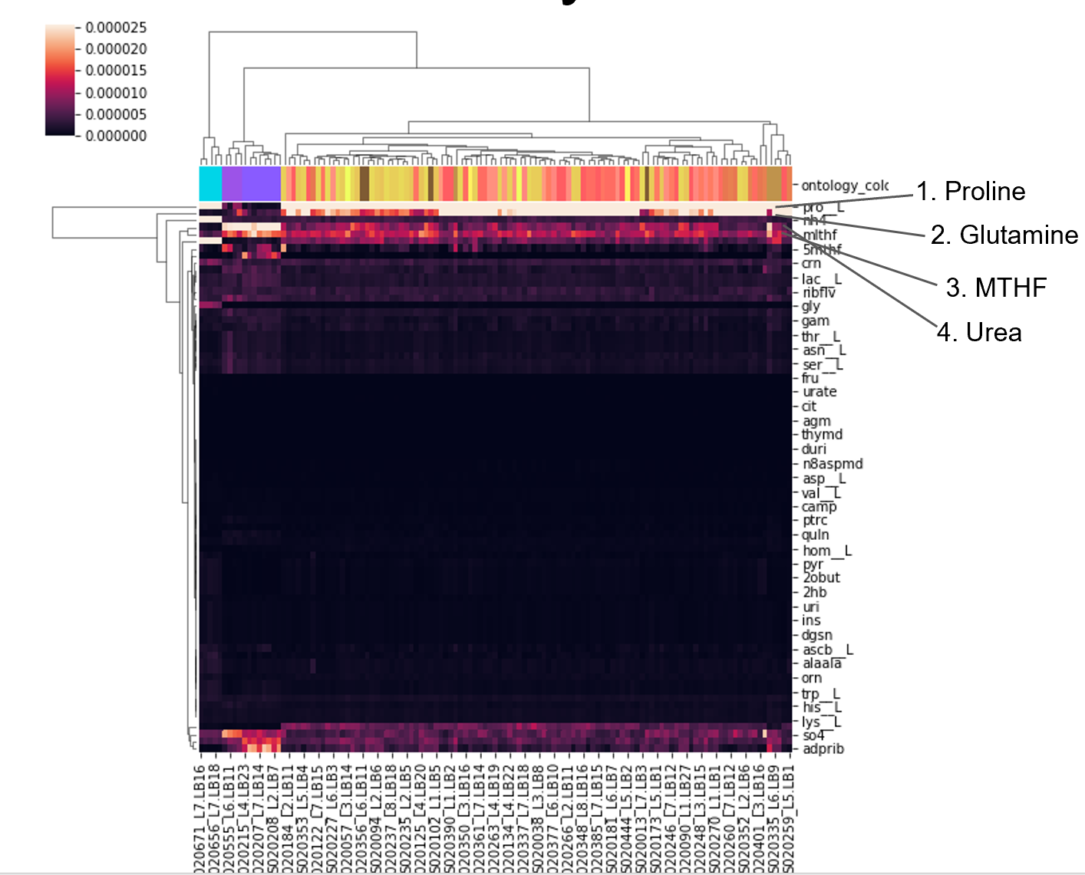

***Figure 3.6:*** *Cluster map of metabolite activities by brain region. The majority of metabolites have very low activities. Structure ontology colors are shown in the row color bar (cyan: cerebellum, purple: deep brain, yellow-brown-orange: cortex), and activities cluster by brain part. Top metabolites are shown on the right.*

This matrix identifies some metabolites that have highly expressed transporters, which include amino acids, relatively larger cofactors, and small metabolites like urea. There are clear differences between the three main brain parts, but the cortex heterogeneity is noisy and unstructured. The majority of metabolites have very low activity. Finally, there are no ‘islands’ were metabolites are transported by a single, fine grain brain structure and no others.

To improve the performance of the model, it is important that this matrix be as large and accurate as possible. Hopefully, the incorporation of additional transporter and metabolite annotations and high resolution single-cell omics would enable higher contrast between brain structures.

**3.2.5. Cheminformatics**

We applied the cheminformatics python package indigo for chemical structure computations.12 This package converts the SMILES structures from our databases into chemical fingerprints, which are long lists of attributes for each molecule. We can then compute the Tanimoto Index, another name for the Jaccard Similarity, between two chemical fingerprints. This is the intersection of the two sets of attributes divided by their union, as shown in **equation 3.2.**

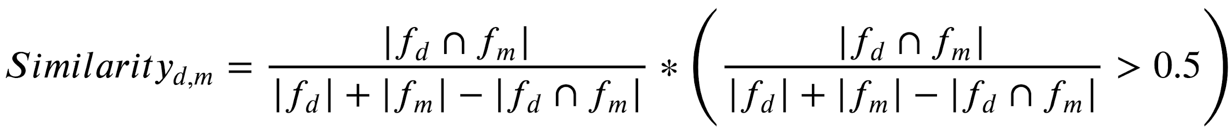 **(Equation 3.2)**

To characterize the metabolites in our dataset and ensure that there is sufficient variation between them for a wide range of drugs, we computed the Tanimoto index between all metabolites in **figure 3.7.** Three high similarity groups arose: amino acids, nucleic acids, and sugars. There was also a group of tricarboxylic acids which had variable similarity and a series of miscellaneous ions and larger metabolites. Overall, we hope that further annotation adds more unique metabolites to the ‘miscellaneous’ category in order to increase coverage, but we believe this set should provide enough variation for a range of unique drugs to have predicted transport.

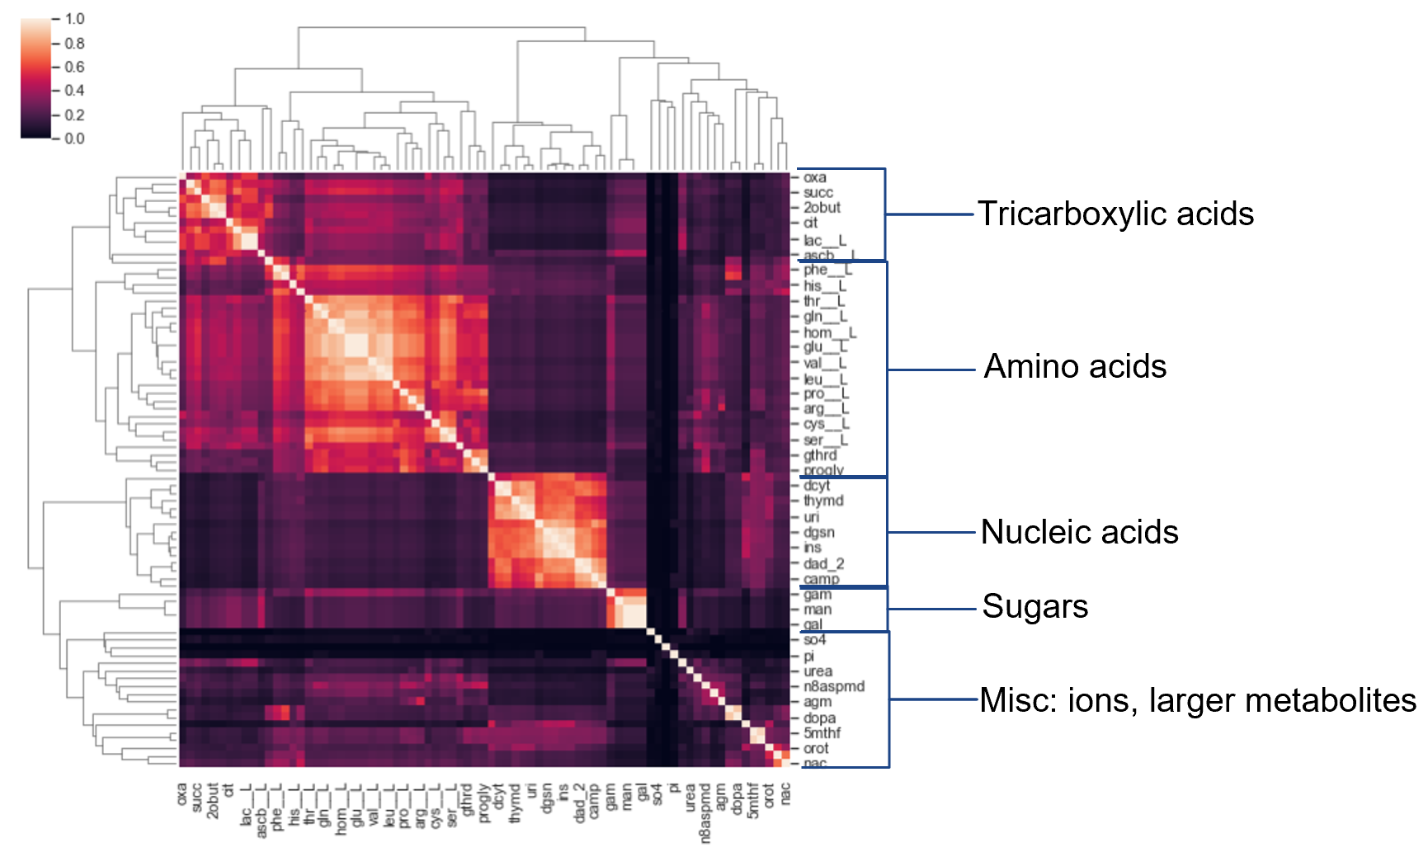

***Figure 3.7:*** *Tanimoto index between all 78 metabolites. Molecules cluster by type of structure as indicated on the right. Variation between metabolites is high enough for sufficient drug coverage, as shown by the dark regions that indicate dissimilar metabolites.*

We next obtain the metabolite/drug similarities for all pairs as shown in **figure 3.8.**

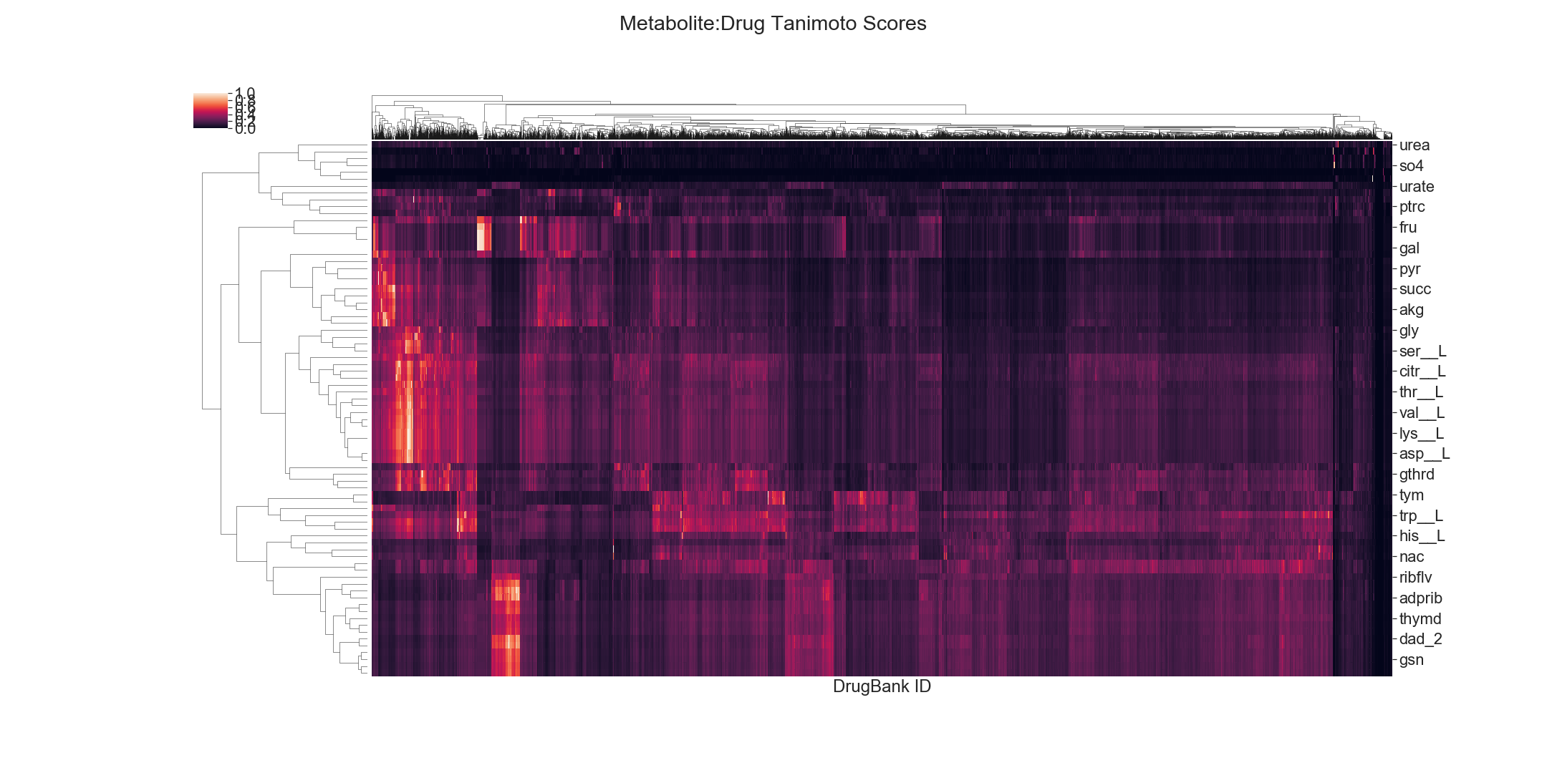

***Figure 3.8:*** *Metabolite/drug Tanimoto index matrix. Metabolites and drugs form groups, and most values are fairly low.*

The rule of 0.5 states that two molecules with Tanimoto indices below 0.5 are unlikely to interact with the same transporters [9]. For example, dopamine and methamphetamine have a Tanimoto index of 0.69 while dopamine and caffeine have a Tanimoto index of 0.21. Methamphetamine can interact with dopamine’s receptors in the brain, but caffeine does not. As a result of this, we will apply a threshold to the Tanimoto indices between drugs and metabolites as illustrated in **equation 3.3** and **figure 3.9.** After removing rows and columns that are all zero, we are left with 2,389 drugs (25% of the original set) and 77 metabolites (removed thiosulfate). Note that despite having a threshold, **equation 3.3** maintains the continuousness of values above 0.5, which allows the model to favor metabolite/drug interactions between molecules that are more similar.

 **(Equation 3.3)**

Python code for generating the data in this section can be found in **appendix 3.3**.

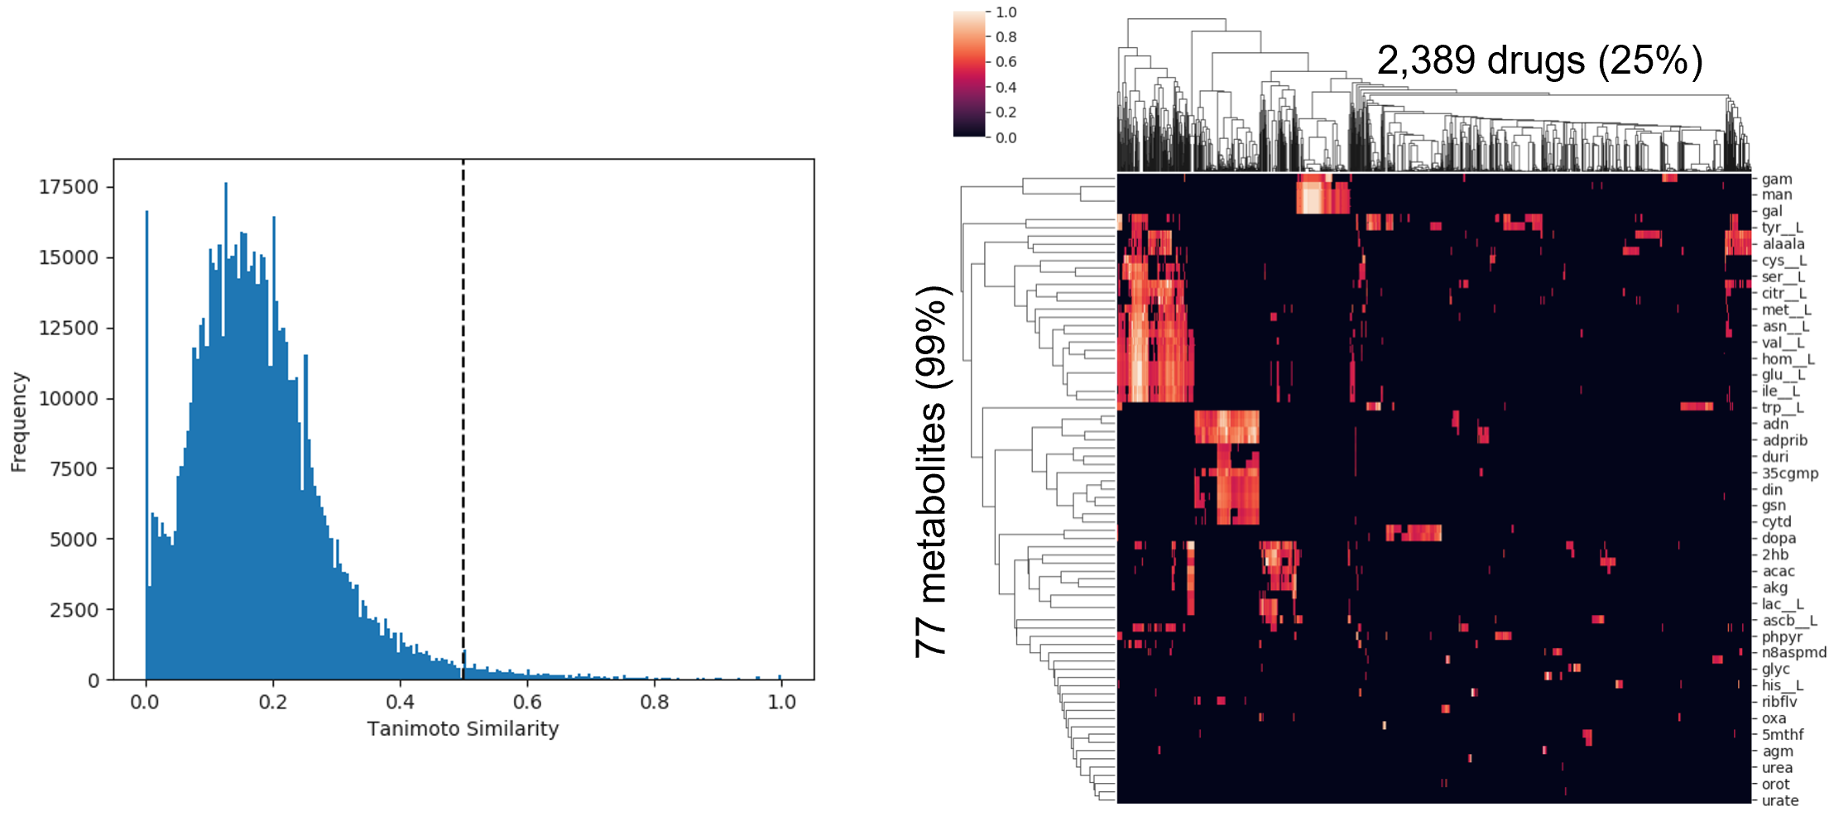

***Figure 3.9:*** *Metabolite/drug Tanimoto indices as a histogram, with rule of 0.5 threshold indicated with black dotted line (left). Metabolite/drug similarity cluster map after the threshold (right). Note that most interactions are below the threshold, which leads to the large drop in number of drugs.*

**3.2.6. Final TADSI Matrix**

Finally, we multiply the transpose of the metabolite/drug similarity matrix in **figure 3.9** by the metabolite/sample activity matrix in **figure 3.6** as shown in **appendix 3.4.** Multiplying these matrices creates a TADSI value for each drug/sample pair which is the sum of all metabolite activities times their similarity to the drug if the drug is similar enough to pass the 0.5 rule. Because the 0.5 rule is better at rejecting drugs that will fail than it is at positively predicting interactions, TADSI values will likely have false positives but be less likely to have false negatives.

We scale the TADSI values by dividing by the standard deviation of the full TADSI set. This makes the numbers more interpretable. Future steps would include normalizing to a specific control transport situation so that TADSIs between datasets can be compared.

**3.3. Results**

**3.3.1. Features of the TADSI Matrix**

The TADSI matrix is shown in **figure 3.10**, and relevant histograms are shown in **figure 3.11**. There is a clear separation between drugs that are taken up (total = 343) and drugs that are not. The matrix is very sparse. Interestingly, the deep brain does not take up any drugs based on these predictions, while the cerebellum has higher values than the cortex for the identified drugs. A close look indicates three clusters of active drugs, which will be analyzed in the following section.

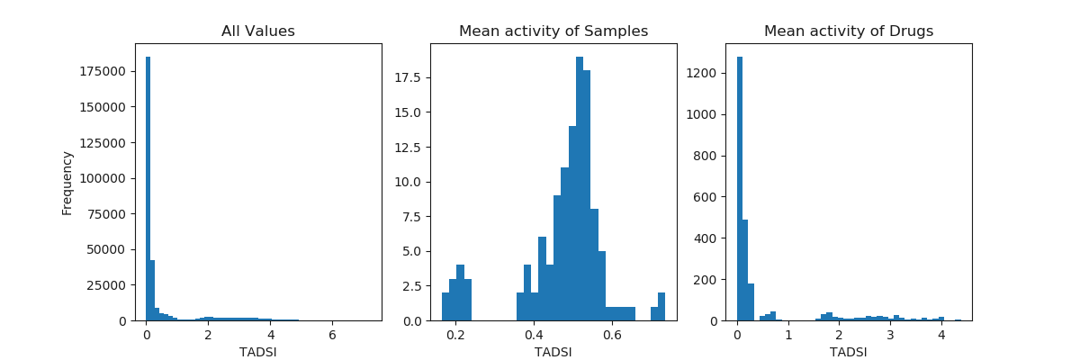

***Figure 3.11:*** *Histograms of all TADSI values (left), mean activity of samples (middle) and mean activity of drugs (right). Note the clear separation between deep brain, cortex, and cerebellum samples in the middle plot and the active drugs above a threshold of TADSI = 1 in the right plot*

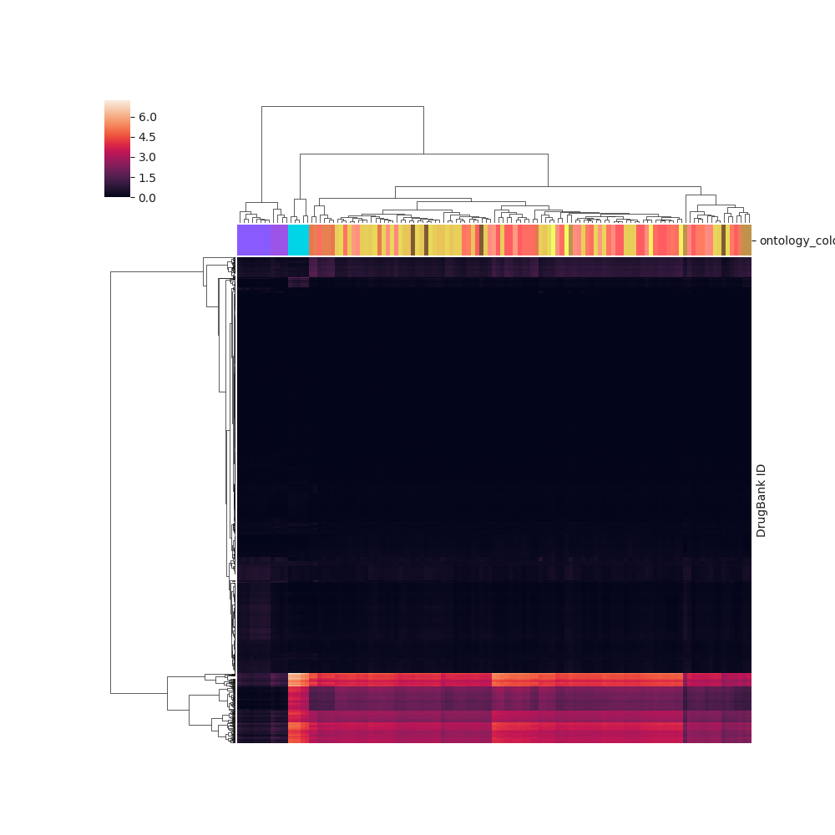

***Figure 3.10:*** *TADSI Matrix. Most drugs (rows) have very low TADSI, while three clusters of TADSIs can be seen at the bottom of the plot. The deep brain (purple column color) does not take up drugs based on these predictions, and the cerebellum (cyan column color) takes up drugs more strongly than the cortex.*

**3.3.2. Drug Clusters**

**Figure 3.12** shows a characterization of the clusters of TADSIs, and code can be found in **appendix 3.4.** A Tanimoto co-similarity matrix was computed for each cluster, and the molecules with maximal mean similarity to the rest of the cluster are shown.

Clusters 1 and 2 represent amino acids. Cluster 1 is made up of amino acids with greater similarity in uptake (TADSI) between the subcortex and cortex, while cluster 2 has high uptake and greater preference for the cerebellum.

Cluster 3 represents larger molecules, which are likely more similar to molecules like MTHF and other relatively large cofactors and peptides. Because these drugs tend to have more interesting and specific activity, the top ten most representative molecules were given greater attention in **table 3.1.** This table demonstrates that though the brain may take up a drug, the drug’s function may not have any impact in the brain. However, one molecule, Rapastinel, is in clinical trials to treat depression and OCD in the brain. These diseases are dysfunctions in the cortex, which our project predicts that Rapastinel will be taken up by. We therefore provide evidence that Rapastinel may be successful, at least at entering its target tissue.

Future improvements as described throughout the workflow (see 3.2.3, 3.2.4) will hopefully allow for clustering at higher resolution than the three brain parts. For now, a prediction of 343 molecules to be taken up by the cortex and cerebellum is a strong proof of concept for this type of analysis, particularly if future experiments can confirm uptake *in vivo* to validate these predictions.

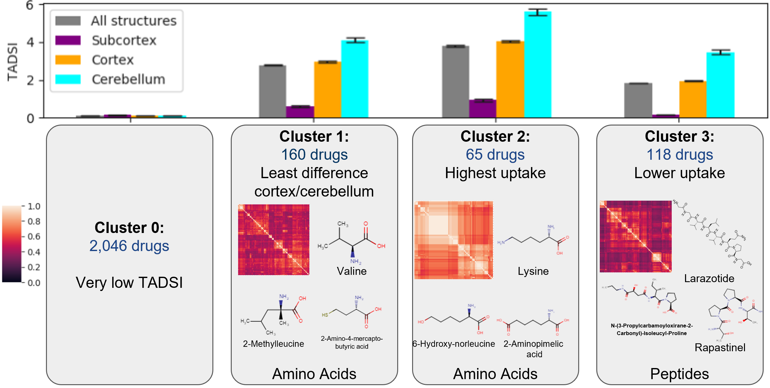

***Figure 3.12:*** *TADSI cluster characterization. The bar graph (mean +/- SEM) indicates TADSI values of drugs in each cluster and brain part. The Tanimoto Index between all members of the cluster is shown in the red matrices, which demonstrates that they are fairly similar, with the most hetereogeneity occuring in cluster 3. The top three most representative molecules (maximal mean Tanimoto Index) are shown with their structures.*

**3.3.3. Differences Between Brain Regions May Result from Neuron Type Variation**

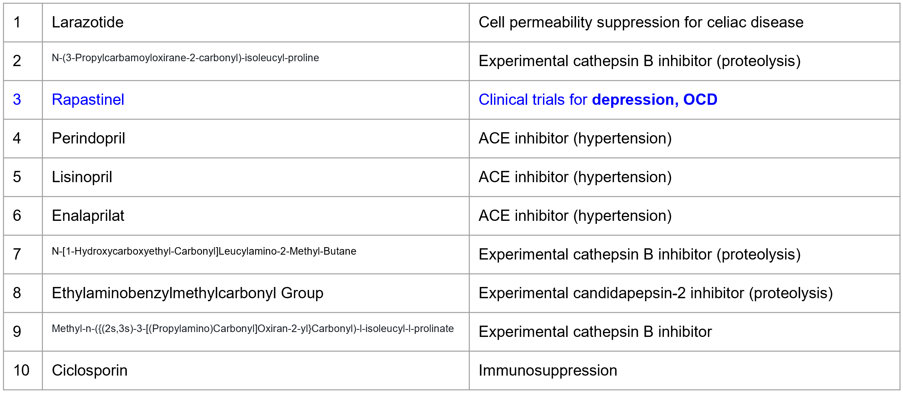

***Table 3.1:*** *Top ten representative drugs of cluster 3 with their main usage. Highlighted in blue is rapastinel, the only drug in the top ten whose main usage is in the brain. This project predicts successful uptake of these drugs by the brain.*

In **figure 3.13,** we present a hypothesis that may contribute to the differential uptake between brain structures. Typical neurons in each structure have various surface area to volume ratios, which increase as TADSI increases as shown. Increased surface area may induce increased transporter expression, which would cause differential uptake in this model. It would be interesting to quantify this relationship in the future.

New research has begun to probe this relationship. The cerebellum has been ignored in many drug studies in the past because its motor function is not the target of most drugs made for the brain. However, drug addiction research is beginning to focus on the cerebellum because of higher drug uptake and structural changes [14], which provides evidence that the relationship observed in this matrix may have real biological implications.

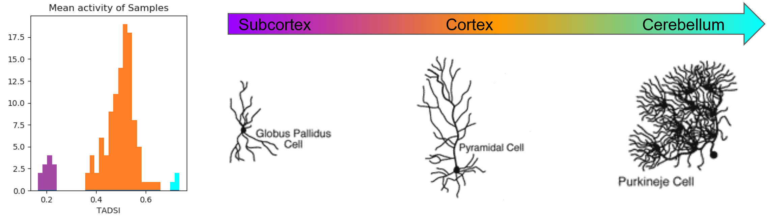

***Figure 3.14:*** *Surface area to volume ratio may play a role in the differential uptake observed. The histogram (left) of TADSI values by sample has been recolored by brain part, which highlights the differential values between the three parts. The cell schematics (right) indicate typical neuron structures in each region, highlighting the differences in surface area.*

**4. Conclusion**

The overall goal of our project was to assess regional specificity of gene expression in the brain. We saw high Pearson correlations amongst similar brain regions without lateralization. Data visualization of the full dataset by PCA showed clustering amongst the cerebellum, cortex, and brainstem. PCA of solely the cortex did not cluster as well as the full dataset. Unsupervised learning assessment of the data highlighted to complexity associated with brain gen expression data. Clustering method had difficulty recapitulating regional information without label information, showing that gene expression data variations are not solely due to regional differences in the brain. Supervised learning assessment showed a decrease in performance as the number of classes increased for all models due to the lack of samples at higher resolutions. All models performed quite well at the 3- and 10-class resolutions. Further fine tuning and feature analysis was performed on the Multinomial Regression and Random Forest models including bootstrapping. Both models were able to highlight interesting regional differences in gene expression at these resolutions with Multinomial Regression highlighting gene expression specific to each region and Random Forest showing genes associated with differences between regions at each decision node. Similar analysis could surely be applied to single cell data to obtain regional differences at the higher resolutions. Additionally, subjects could be pooled to determine if increasing the number of samples would allow for further biological analysis.

A mapping of gene expression data across transporter, metabolite, and drug database information allowed for the creation of a **T**ransport **A**ctivity/**D**rug **S**imilarity **I**ndex matrix. PCA of transporter data strongly reflected PCA of the full dataset, allowing for dimensionality reduction. Metabolites were mapped to brain region with the majority of metabolites displaying low activities. The most active metabolites were the two amino acids, proline and glutamine, the large molecule MTHF, and urea. Upon calculation of the Tanimoto index between all metabolites, it was found that metabolites cluster by structure type. Metabolites were then mapped to drugs forming groups although most values were fairly low. By mapping the metabolites over to chemically similar drugs using the Tanimoto Index and following the rule of 0.5 threshold, we created a highlighting the likelihood of finding certain drugs within each brain region. For most drugs, it was unlikely to find any significant expression within the brain but for those that did show activity, the cerebellum showed the most drug uptake followed by the cortex then the deep brain. Furthermore, the drugs clusters into three main cluster, two of which were amino acids but one cluster showed preferential uptake in the brainstem and cortex while the other showed preference for the cerebellum. The last cluster represented large molecules generally more representative of pharmaceuticals. Of the top ten most representative molecules in that cluster, one molecule, Rapastinel, has a neurological-based purpose. It is currently in clinical trials to treat depression and OCD. Additionally, we propose the larger activity in cerebellum is due to purkineje cells of the cerebellum having a higher surface area to volume ratio than pyramidal cells common in the cortex which have a higher ratio still than cells associated with the brainstem.

Overall, our analyses created some interesting insight to the brain and highlights some of the data analysis techniques that can be applied to RNA-sequencing data to obtain useful results. Additionally, we have shown the complexity associated with sequencing genetic expression in the brain as compared to simpler organisms which have previously bene analyzed with similar techniques. With the inclusion of single cell data, more samples, and a complete list of metabolite transporters, this analysis could be further elevated to better understand the brain.

**5. References**

1. 2010 Allen Institute for Brain Science. Allen Human Brain Atlas. Available from:[human.brain-map.org](http://human.brain-map.org/)
2. Shen, E.H., Overly, C.C., Jones, A.R. The Allen Human Brain Atlas: comprehensive gene expression mapping of the human brain. *Trends Neurosci* vol. 35, 12 (2012): 711-4.
3. Kukurba, K.R., Montgomery, S.B. RNA Sequencing and Analysis. *Cold Spring Harb Protoc* vol. 11 (2015): 951-69.
4. Hawrylycz, M.J. *et al.* An anatomically comprehensive atlas of the adult human brain transcriptome. *Nature* vol. 489 (2012): 391-99.
5. Hawrylycz, M. *et al.* Canonical genetic signatures of the adult human brain. *Nature Neuroscience* vol 18 (2015): 1832-44.
6. Mendes, P., Oliver, S.G., Kell, D.B. Fitting Transporter Activities to Cellular Drug Concentrations and Fluxes: Why the Bumblebee Can Fly. *Trend Pharmacol Sci* vol. 36, 11 (2015): 710-23.
7. Bajusz, D., Racz, A., Heberge, K. Why is Tanimoto index an appropriate choice for fingerprint-based similarity calculations? *Journal of Cheminformatics* vol. 7, 20 (2015)
8. P.D. Dobson, D.B. Kell, Carrier-mediated cellular uptake of pharmaceutical drugs: an exception or the rule?, *Nature Reviews Drug Discovery*. 7 (2008) 205–220. doi:[10.1038/nrd2438](https://doi.org/10.1038/nrd2438).
9. S. O′Hagan, N. Swainston, J. Handl, D.B. Kell, A ‘rule of 0.5’ for the metabolite-likeness of approved pharmaceutical drugs, *Metabolomics*. 11 (2015) 323–339. doi:10.1007/s11306-014-0733-z.
10. Wishart DS, et al. DrugBank 5.0: a major update to the DrugBank database for 2018. Nucleic Acids Res. 2017 Nov 8. doi: 10.1093/nar/gkx1037.
11. E. Brunk, et al., Recon3D enables a three-dimensional view of gene variation in human metabolism, Nat. Biotechnol. 36 (2018) 272–281. doi:10.1038/nbt.4072.
12. D. Pavlov, M. Rybalkin, B. Karulin, M. Kozhevnikov, A. Savelyev, A. Churinov, Indigo: universal cheminformatics API, J Cheminform. 3 (2011) P4. doi:[10.1186/1758-2946-3-S1-P4](https://doi.org/10.1186/1758-2946-3-S1-P4).
13. Entrez Help [Internet]. Bethesda (MD): National Center for Biotechnology Information (US); 2005-. Entrez Help. 2006 Jan 20 [Updated 2016 May 31].
14. Moulton, Eric A et al. “The cerebellum and addiction: insights gained from neuroimaging research” *Addiction biology* vol. 19,3 (2014): 317-31.
15. A. Oshlack, M.J. Wakefield, Transcript length bias in RNA-seq data confounds systems biology, Biol. Direct. 4 (2009) 14. doi:10.1186/1745-6150-4-14.
16. A. Conesa, P. Madrigal, S. Tarazona, D. Gomez-Cabrero, A. Cervera, A. McPherson, M.W. Szcześniak, D.J. Gaffney, L.L. Elo, X. Zhang, A. Mortazavi, A survey of best practices for RNA-seq data analysis, Genome Biol. 17 (2016) 13. doi:10.1186/s13059-016-0881-8.
17. GeneCards Human Gene Database. Weizmann Institute of Science. 6 (2019).
18. Babu, MM, Luscombe, NM, Aravind, L, Gerstein, M, Teichmann, SA. Structure and evolution of transcriptional regulatory networks. *Current Opinion in Structural Biology.* **14**, 3 (2004): 283-91.
19. Vasiliou, V., Vasiliou, K., Nebert, D.W. Human ATP-binding cassette (ABC) transporter family. *Hum Genomics.* 3, 3 (2009): 281-90.
20. Hobert, O., Westphal, H. Functions of LIM-homeobox genes. *Trends Genet.* 16, 2 (2000): 75-83.
21. Srivastava, M. et al. Early evolution of the LIM homeobox gene family. *BMC Biol.* 8, 4 (2010).
22. Vendrell-Llopis, N., Yaksi, E. Evolutionary conserved brainstem circuits encode category, concentration and mixtures of taste. *Scientific Reports*. 5 (2015).
23. National Institutes of Health (US); Biological Sciences Curriculum Study. NIH Curriculum Supplement Series [Internet]. Bethesda (MD): National Institutes of Health (US); 2007. Information about Mental Illness and the Brain.

**6. Appendix**

**6. Appendix**

**6.2.1. Multinomial Regression Including Bootstrapping**

''' Generic bootstrapping test function to evaluate

performance of each model.'''

from sklearn.utils import resample

from sklearn.base import clone

import sklearn.utils, sklearn.base, sklearn.metrics, sklearn.model_selection

def bootstrap_model(X, y, clf, iterations=100, bootstrap_fraction=0.8,

is_classifier=True, plot=True):

''' Bootstrapping function to evaluate model performance

in terms of performance on the training set vs testing set '''

n = len(y)

n_bootstrap = int(bootstrap_fraction * n)

train_set_performance = np.zeros(iterations) # store training set performance for each model

test_set_performance = np.zeros(iterations) # store testing set performance for each model

models = [] # store all fitted models

for i in range(iterations):

''' Construct the training/testing sets '''

y_train = np.zeros(n_bootstrap)

while y_train.sum() == 0 or y_train.sum() == n_bootstrap:

''' Resample until training set is not all same class '''

training_indices = resample(range(n), n_samples=n_bootstrap) # sample with replacement

testing_indices = [x for x in range(n) if x not in training_indices] # "out-of-bag" data points

X_train = X[training_indices,:]

y_train = y[training_indices]

X_test = X[testing_indices,:]

y_test = y[testing_indices]

''' Train the classifier '''

clf_bootstrap = clone(clf)

clf_bootstrap.fit(X_train, y_train)

yhat_train = clf_bootstrap.predict(X_train)

yhat_test = clf_bootstrap.predict(X_test)

models.append(clf_bootstrap)

''' Evaluate using MCC for classifiers, R^2 for regression '''

if is_classifier:

perf_train = sklearn.metrics.matthews_corrcoef(y_train, yhat_train)

perf_test = sklearn.metrics.matthews_corrcoef(y_test, yhat_test)

else:

perf_train = sklearn.metrics.r2_score(y_train, yhat_train)

perf_test = sklearn.metrics.r2_score(y_test, yhat_test)

train_set_performance[i] = perf_train

test_set_performance[i] = perf_test

''' Generate performance histogram '''

if plot:

bins = np.arange(0,1.05,0.05)

metric = 'MCC' if is_classifier else 'R2'

print('Average training set ' + metric + ':', np.mean(train_set_performance))

print('Average testing set ' + metric + ':', np.mean(test_set_performance))

plt.hist(train_set_performance, bins=bins, alpha=0.7, label='Train Set')

plt.hist(test_set_performance, bins=bins, alpha=0.7, label='Test Set')

plt.xlabel(metric); plt.ylabel('count')

plt.title('Bootstrapping Performance')

plt.legend()

return train_set_performance, test_set_performance, models

def resample_confidence_interval(samples, alpha=0.95):

''' Compute non-parametric confidence interval from resampling. Adapted from

https://machinelearningmastery.com/calculate-bootstrap-confidence-intervals-machine-learning-results-python/ '''

p = ((1.0-alpha)/2.0) * 100

lower = np.percentile(samples, p)

p = (alpha+((1.0-alpha)/2.0)) * 100

upper = np.percentile(samples, p)

return lower, upper

'''Use bootstrapping'''

from sklearn.linear_model import LogisticRegression

Xnorm = X.values

clf_lr = LogisticRegression(class_weight='balanced',multi_class='multinomial',solver='lbfgs')

''' Bootstrapping to describe performance '''

train_set_performance_3lr_pcs, test_set_performance_3lr_pcs, models_3lr_pcs = bootstrap_model(X=Xnorm, y=y_pcs, clf=clf_lr,

iterations=100, bootstrap_fraction=0.8, is_classifier=True)

''' Fitting to whole dataset to find meaningful features,

sorted by absolute value of coefficient '''

clf_lr.fit(X=Xnorm, y=y_pcs)

for structure in range(10):

weights = clf_lr.coef_[structure,:]

df_coef = pd.DataFrame(index=X.columns)

df_coef['coef'] = weights

df_coef['|coef|'] = np.abs(weights)

df_coef = df_coef.sort_values(by='|coef|', ascending=False)

display(df_coef.head(10))

''' Aggregate all 500 testing set performances from 100 iterations of 5-fold CV '''

iterations = 100

cv_scores = []

for i in range(iterations):

''' Randomly shuffle the observations before each CV '''

indices = list(range(len(y_pcs)))

np.random.shuffle(indices)

X_cv = Xnorm[indices,:]

y_cv = y_pcs[indices]

''' Apply 5-fold CV'''

reg = LogisticRegression(class_weight='balanced',multi_class='multinomial',solver='lbfgs')

scores = sklearn.model_selection.cross_val_score(

estimator=reg, X=X_cv, y=y_cv, cv=5, scoring='accuracy')

cv_scores += scores.tolist()

cv_scores = np.array(cv_scores)

cv_lower, cv_upper = resample_confidence_interval(cv_scores)

print('Performance 95% confidence intervals')

print('Cross-Validation Accuracy:', round(cv_lower,3), 'to', round(cv_upper,3))

**6.2.1. Random Forest Including Bootstrapping**

from sklearn.ensemble import RandomForestClassifier

'''Use bootstrapping'''

Xnorm = X.values

clf_rf = RandomForestClassifier(class_weight='balanced',n_estimators=100)

''' Bootstrapping to describe performance '''

train_set_performance_rfpcs, test_set_performance_rfpcs, models_rfpcs = bootstrap_model(X=Xnorm, y=y_pcs, clf=clf_rf,

iterations=100, bootstrap_fraction=0.8, is_classifier=True)

''' Fitting to whole dataset to find meaningful features,

sorted by absolute value of coefficient '''

clf_rf.fit(X=Xnorm, y=y_pcs)

weights = clf_rf.feature_importances_

df_coef = pd.DataFrame(index=X.columns)

df_coef['coef'] = weights

df_coef['|coef|'] = np.abs(weights)

df_coef = df_coef.sort_values(by='|coef|', ascending=False)

df_top = df_coef.head(10)

df_top

''' 95% confidence intervals on performance '''

train_CI = resample_confidence_interval(train_set_performance_rfpcs)

test_CI = resample_confidence_interval(test_set_performance_rfpcs)

print('Performance 95% confidence intervals')

print('Training MCC:', round(train_CI[0],3), 'to', round(train_CI[1],3))

print(' Testing MCC:', round(test_CI[0],3), 'to', round(test_CI[1],3))

import graphviz

import sklearn.tree

from random import randint

''' Render graph in notebook '''

sample_tree = randint(0,100)

estimator = clf_rf.estimators_[sample_tree]

dot_data = sklearn.tree.export_graphviz(estimator, out_file=None,

feature_names=X.columns, class_names=['Cerebellum','Subcortex','Cortex'],

filled=True, rounded=True,precision=2)

graph = graphviz.Source(dot_data)

graph

**6.2.2. 10-Class Multinomial Regression Top Features**

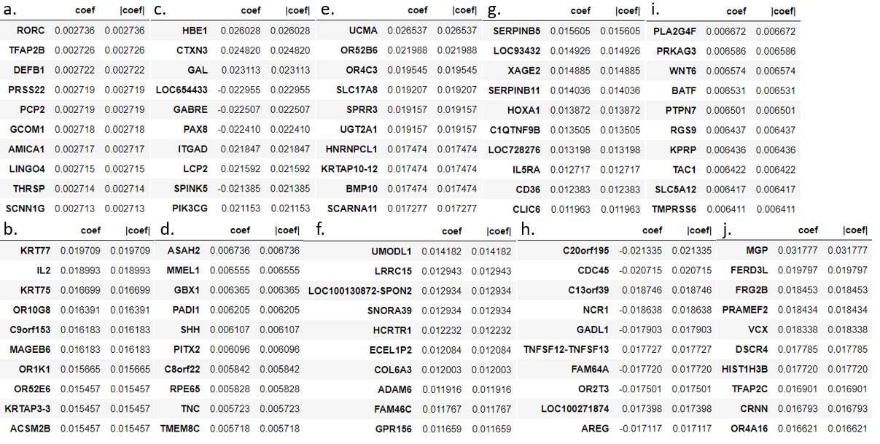

***Fig 6.2.1:*** *Top 10 highest weighted genes for the Multinomial Regression 10-class resolution model for the cerebellum (a), cingulate gyrus (b), frontal lobe (c), globus pallidus (d), insula (e), occipital lobe (f), parahippocampal gyrus (g),parietal lobe (h), striatum (i), temporal lobe (j).*

**6.2.3. Sample Trees for 10-Class Random Forest Model**

(a)

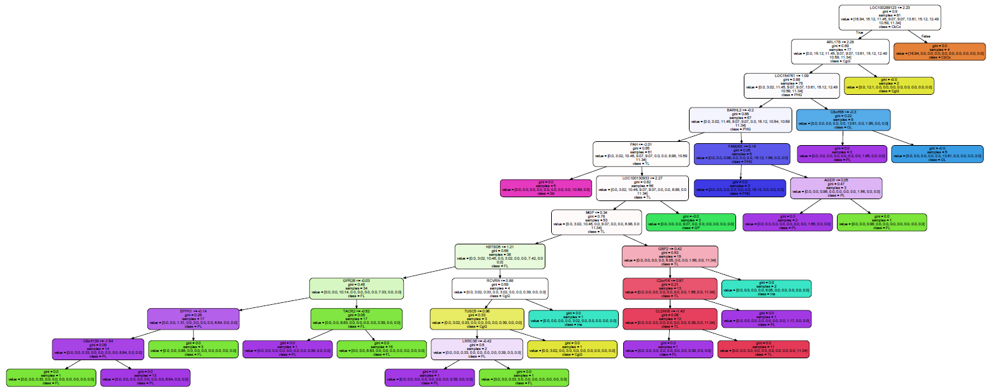

(b)

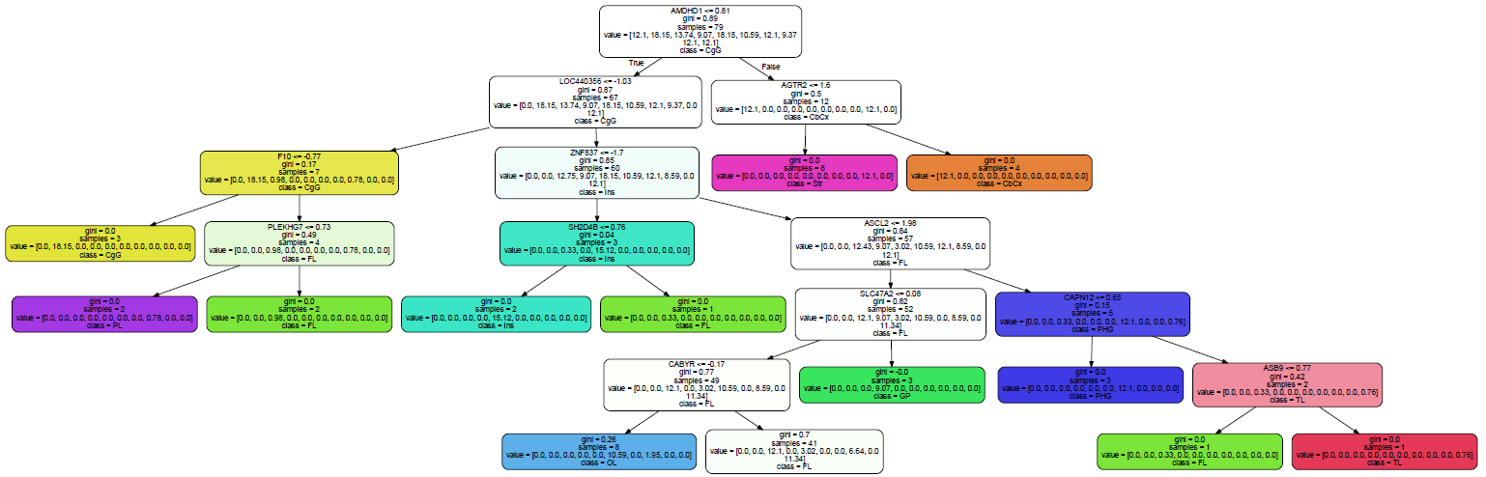

***Fig 6.2.2:*** *Sample trees for 10-class resolution (a) and regularized 10-class resolution (b).*

**6.3.1. Transporter Reactions and Genes Data Curation**

rxn_met_info = pd.read_csv('Hypothesis - Transporters.csv')

# only keep transporters with known structures

rxn_met_info = rxn_met_info.loc[np.where([isinstance(rxn_met_info.loc[i, 'SMILES Structure'], basestring) for i in rxn_met_info.index])]

print 'There are %i transporters with known structures in the database.' %(len(rxn_met_info.index))

# rxn_geneID_map from RECON3D

import cobra

model = cobra.io.read_sbml_model('RECON3D.xml')

rxn_geneID_map = {}

for i in rxn_met_info.index:

geneID = model.reactions.get_by_id(rxn_met_info.loc[i, 'Reaction']).gene_reaction_rule

if geneID == '':

rxn_met_info.drop([i])

else:

# note that the Entrez geneID appears before the underscore

rxn_geneID_map[i] = [g.partition('_')[0] for g in cobra.core.gene.parse_gpr(geneID)[1]]

# list all potential genes for Entrez lookup

geneID_list = set()

for k, v in rxn_geneID_map.iteritems():

geneID_list = geneID_list | set(v)

geneID_list = list(geneID_list)

# get geneID_gene_map from Entrez

from Bio import Entrez

Entrez.email = 'krychel@eng.ucsd.edu'

search_res = Entrez.read(Entrez.epost(db = 'gene', id = ','.join(geneID_list)))

webEnv = search_res["WebEnv"]

queryKey = search_res["QueryKey"]

tg_data = Entrez.esummary(db="gene", webenv=webEnv, query_key = queryKey)

summaries = Entrez.read(tg_data)

summaries = summaries['DocumentSummarySet']

summaries = summaries['DocumentSummary']

geneID_gene_map = pd.Series()

for gID, s in zip(geneID_list, summaries):

geneID_gene_map[gID] = s['NomenclatureSymbol']

# clean up the geneID_gene_map

# change some names to match the main dataset

aliases = {'CLTRN':'TMEM27',

'SLC52A1':'GPR172B',

'SLC52A3':'C20orf54',

'SLC52A2':'GPR172A'}

for i in geneID_gene_map.index:

if geneID_gene_map[i] in aliases.keys():

geneID_gene_map[i] = aliases[geneID_gene_map[i]]

# delete all the genes that don't appear in the cleaned up dataset

to_drop = [i for i in geneID_gene_map.index if geneID_gene_map[i] not in data.index]

print 'Removing %i genes associated with transporters that do not have good expression data'%(len(to_drop))

geneID_gene_map = geneID_gene_map.drop(to_drop)

print 'There are now %i transporter genes' % (len(geneID_gene_map))

**6.3.2. Gene:Reaction Mapping**

# create rxn_gene_map, gene_rxn_map, met_rxn_map, and met_smiles_map

rxn_gene_map = {}

gene_rxn_map = {} # inverse of above

met_rxn_map = {}

met_smiles_map = {}

for r,gIDset in rxn_geneID_map.iteritems():

g_set = []

for gID in gIDset:

if gID in geneID_gene_map.index:

g_set += [geneID_gene_map[gID]]

if g_set:

# rxn_gene_map

rxn_gene_map[r] = g_set

# metabolites

met = rxn_met_info.loc[r, 'Transported Metabolite']

if met in met_rxn_map:

met_rxn_map[met] += [r]

else:

met_rxn_map[met] = [r]

met_smiles_map[met] = rxn_met_info.loc[r, 'SMILES Structure']

# gene_rxn_map

for g in g_set:

if g in gene_rxn_map:

gene_rxn_map[g] += [r]

else:

gene_rxn_map[g] = [r]

# gene_sample_DF: the transporter subset of the full dataset 'data'

gene_sample_DF = data.loc[gene_rxn_map.keys(), :]

# rxn_sample_DF: convert genes to reactions

rxn_sample_DF = pd.DataFrame(np.zeros((len(rxn_gene_map), len(gene_sample_DF.columns))),

index = rxn_gene_map.keys(), columns = gene_sample_DF.columns)

for r in rxn_sample_DF.index:

genes = rxn_gene_map[r]

for g in genes:

# the activity will be normalized to the number of unique transport events

rxns_this_gene = gene_rxn_map[g]

unique_rxns_this_gene = np.unique(rxn_met_info.loc[rxns_this_gene, 'Reaction'])

denom = len(unique_rxns_this_gene)

for s in rxn_sample_DF.columns:

rxn_sample_DF.loc[r, s] += gene_sample_DF.loc[g, s]/denom

**6.3.2. Cheminformatics**

# read in the drugbank file

drug_smiles_info = pd.read_csv('drug structure links.csv', index_col = 0)

drug_smiles_info = drug_smiles_info.iloc[np.where([isinstance(drug_smiles_info.loc[i, 'SMILES'], basestring) for i in drug_smiles_info.index])]

print 'There are %i drugs with known structures in the database.'%(len(drug_smiles_info.index))

# import the indigo toolbox for cheminformatics tools

import sys

sys.path.append('indigo')

from indigo import *

from bingo import *

indigo = Indigo()

# write a function for the similarity between two molecules

def chem_sim(smiles1, smiles2, fp_type = 'sim', sim_index = 'tanimoto'):

m1 = indigo.loadMolecule(smiles1)

m2 = indigo.loadMolecule(smiles2)

# if a molecule is aromatic, the following commands will make sure

# that the notations match up

m1.aromatize()

m2.aromatize()

# this creates the feature list (fingerprint) used to compare

fp1 = m1.fingerprint(fp_type)

fp2 = m2.fingerprint(fp_type)

#return the similarity

return indigo.similarity(fp1, fp2, sim_index)

# some of the drugbank smiles structures fail in indigo. Remove them.

mol2 = drug_smiles_info.loc['DB00470', 'SMILES'] # pick a random drug that works

bad_drugs = []

for m in drug_smiles_info.index:

try:

chem_sim(drug_smiles_info.loc[m, 'SMILES'], mol2)

except:

bad_drugs += [m]

drug_smiles_info = drug_smiles_info.drop(bad_drugs)

print 'Removed %i drugs with bad structures. New total: %i'%(len(bad_drugs), len(drug_smiles_info.index)) # len(bad_drugs) = 9, new total: 9287

# Generate met_drug_DF, which is the tanimoto similarities of all metabolites and drugs

met_drug_DF = pd.DataFrame(np.ones((len(met_sample_DF.index), len(drug_smiles_info.index))),

index = met_sample_DF.index, columns = drug_smiles_info.index)

for m in tqdm(met_sample_DF.index):

for d in (drug_smiles_info.index):

met_drug_DF.loc[m, d] = chem_sim(met_smiles_map[m], drug_smiles_info.loc[d, 'SMILES'])

# apply the rule of 0.5

met_drug_thresh_DF = met_drug_DF.copy()

for m in tqdm(met_drug_thresh_DF.index):

for d in met_drug_thresh_DF.columns:

if met_drug_thresh_DF.loc[m,d] < 0.5:

met_drug_thresh_DF.loc[m,d] = 0

# eliminate rows and columns that are zero

mets_no_sim_drug = []

drugs_no_sim_met = []

row_total = met_drug_thresh_DF.sum(axis = 1)

for r in row_total.index:

if row_total[r] == 0:

mets_no_sim_drug += [r]

print 'Removing %i metabolites with no matching drugs:'%(len(mets_no_sim_drug)), mets_no_sim_drug

col_total = met_drug_thresh_DF.sum(axis = 0)

for c in col_total.index:

if col_total[c] == 0:

drugs_no_sim_met += [c]

print 'Removing %i drugs with no matching metabolites.'%(len(drugs_no_sim_met))

met_sample_DF= met_sample_DF.drop(mets_no_sim_drug)

met_drug_thresh_DF= met_drug_thresh_DF.drop(mets_no_sim_drug)

met_drug_thresh_DF= met_drug_thresh_DF.drop(drugs_no_sim_met, axis = 1)

print 'met_sample_DF shape: ', met_sample_DF.shape

print 'met_drug_thresh_DF shape: ', met_drug_thresh_DF.shape

**6.3.3. Final TADSI Matrix**

drug_sample_DF = pd.DataFrame(np.dot(met_drug_thresh_DF.transpose(), met_sample_DF),

index = met_drug_thresh_DF.columns, columns = met_sample_DF.columns)

# normalize the matrix so its overall std dev is 1

# this preserves the differences and the minimum of zero while making numbers more interpretable

ds_std = np.std(drug_sample_DF.values.ravel())

drug_sample_DF = drug_sample_DF.divide(ds_std)

**6.3.4. Drug Clusters**

drug_cluster_map = pd.Series(AgglomerativeClustering(n_clusters = 4, linkage = 'average').fit(drug_sample_DF).labels_, index = drug_sample_DF.index)

cluster_drug_map = {}

for i in range(4):

cluster_drug_map[i] = drug_cluster_map.index[np.where(drug_cluster_map == i)]

from scipy.stats import sem

cluster_info = pd.DataFrame(columns = range(4), index = ['Number of Drugs', 'Mean TADSI', 'SEM',

'Cerebellar TADSI', 'Cerebellar SEM',

'Cortical TADSI', 'Cortical SEM',

'Subcortical TADSI', 'Subcortical SEM'])

def cluster_stats(c):

length = int(len(c))

mean = np.mean(drug_sample_DF.loc[c].mean(axis = 1))

tadsi_sem = sem(drug_sample_DF.loc[c].mean(axis = 1))

TASDI = drug_sample_DF.loc[c].mean(axis = 0)

cerebellum_structures = ['CbCx']

subcortical_structures = ['GP', 'Str']

cereb = np.mean(TASDI.iloc[np.where([s in cerebellum_structures for s in samples.main_structure])])

cereb_sem = sem(TASDI.iloc[np.where([s in cerebellum_structures for s in samples.main_structure])])

subcort= np.mean(TASDI.iloc[np.where([s in subcortical_structures for s in samples.main_structure])])

subcort_sem = sem(TASDI.iloc[np.where([s in subcortical_structures for s in samples.main_structure])])

cort = np.mean(TASDI.iloc[np.where([s not in cerebellum_structures + subcortical_structures

for s in samples.main_structure])])

cort_sem = sem(TASDI.iloc[np.where([s not in cerebellum_structures + subcortical_structures

for s in samples.main_structure])])

return [length, mean, tadsi_sem, cereb, cereb_sem, cort, cort_sem, subcort, subcort_sem]

for k, v in cluster_drug_map.iteritems():

cluster_info[k] = cluster_stats(v)

cluster_info

barwidth = 0.15

r1 = np.arange(4)

r2 = [x + barwidth for x in r1]

r3 = [x + barwidth for x in r2]

r4 = [x + barwidth for x in r3]

fig, ax = plt.subplots(figsize = (10, 1.6))

ax.bar(r1, cluster_info.loc['Mean TADSI'], color = 'gray', width = barwidth, label = 'All structures', yerr = cluster_info.loc['SEM'], capsize = 7)

ax.bar(r2, cluster_info.loc['Subcortical TADSI'], color = 'purple', width = barwidth, label = 'Subcortex', yerr = cluster_info.loc['Subcortical SEM'], capsize = 7)

ax.bar(r3, cluster_info.loc['Cortical TADSI'], color = 'orange', width = barwidth, label = 'Cortex', yerr = cluster_info.loc['Cortical SEM'], capsize = 7)

ax.bar(r4, cluster_info.loc['Cerebellar TADSI'], color = 'cyan', width = barwidth, label = 'Cerebellum', yerr = cluster_info.loc['Cerebellar SEM'], capsize = 7)

ax.set_xticks([0.22, 1.22, 2.22, 3.22])

ax.set_xticklabels(np.arange(4))

ax.set_ylabel('TADSI')

ax.legend()

plt.savefig('TADSI structure plot.png')

# drug:drug similarity within clusters

cluster_tanimoto = []

for k, v in cluster_drug_map.iteritems():

if k == 0:

continue

clus_DF = pd.DataFrame(np.ones((len(v), len(v))), index = v, columns = v)

for d1, d2 in itertools.combinations(v, 2):

clus_DF.loc[d1, d2] = chem_sim(drug_smiles_info.loc[d1, 'SMILES'], drug_smiles_info.loc[d2, 'SMILES'])

clus_DF.loc[d2, d1] = chem_sim(drug_smiles_info.loc[d1, 'SMILES'], drug_smiles_info.loc[d2, 'SMILES'])

cluster_tanimoto = cluster_tanimoto + [clus_DF]

# save drug similarity clustermaps

for i in range(3):

sns.clustermap(cluster_tanimoto[i], vmin = 0, vmax = 1)

plt.savefig('Cluster Tanimoto %i.png'%(i+1))